- Write a Java program to print 'Hello' on screen and then print your name on a separate line.
Expected Output :
Hello
Your name
- Write a Java program to print the sum of two numbers.
Test Data:
74 + 36
Expected Output :
110
- Write a Java program to divide two numbers and print on the screen.
Test Data :
50/3
Expected Output :
16
- Write a Java program to print the result of the following operations.
Test Data:
a. -5 + 8 * 6
b. (55+9) % 9
c. 20 + -3*5 / 8
d. 5 + 15 / 3 * 2 - 8 % 3
Expected Output :
43
1
19
13
- Write a Java program that takes two numbers as input and display the product of two numbers.
Test Data:
Input first number: 25
Input second number: 5
Expected Output :
25 x 5 = 125
- Write a Java program to print the sum (addition), multiply, subtract, divide and remainder of two numbers.
Test Data:
Input first number: 125
Input second number: 24
Expected Output :
125 + 24 = 149
125 - 24 = 101
125 x 24 = 3000
125 / 24 = 5
125 mod 24 = 5
- Write a Java program to display the following pattern.
Sample Pattern :
J a v v a
J a a v v a a
J J aaaaa V V aaaaa
JJ a a V a a

- Write a Java program to compute the specified expressions and print the output.
Test Data:
((25.5 * 3.5 - 3.5 * 3.5) / (40.5 - 4.5))
Expected Output
2.138888888888889
- Write a Java program to compute a specified formula.
Specified Formula:
4.0 * (1 - (1.0/3) + (1.0/5) - (1.0/7) + (1.0/9) - (1.0/11))
Expected Output
2.9760461760461765
- Write a Java program to print the area and perimeter of a circle.
Test Data:
Radius = 7.5
Expected Output
Perimeter is = 47.12388980384689
Area is = 176.71458676442586
- Write a Java program that takes three numbers as input to calculate and print the average of the numbers.
- Write a Java program to print the area and perimeter of a rectangle.
Test Data:
Width = 5.5 Height = 8.5
Expected Output
Area is 5.6 * 8.5 = 47.60
Perimeter is 2 * (5.6 + 8.5) = 28
- Write a Java program to print patterns on the screen.
Expected Output
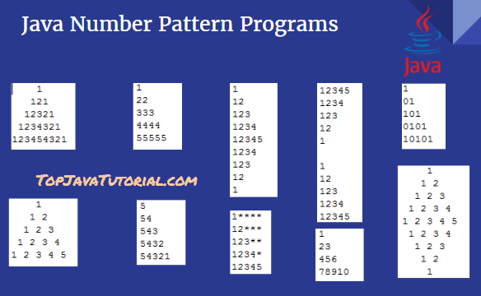
- Write a Java program to swap two variables.
- Write a Java program to convert temperature from Fahrenheit to Celsius degree
Test Data
Input a degree in Fahrenheit: 212
Expected Output:
212.0 degree Fahrenheit is equal to 100.0 in Celsius
- Write a Java program that reads a number in inches, converts it to meters. Note: One inch is 0.0254 meter.
Test Data
Input a value for inch: 1000
Expected Output :
1000.0 inch is 25.4 meters
- Write a Java program to convert minutes into a number of years and days. Test Data
Input the number of minutes: 3456789
Expected Output :
3456789 minutes is approximately 6 years and 210 days
- Write a Java program that reads a number and display the square, cube, and fourth power.
Expected Output:
Square: .2f
Cube: .2f
Fourth power: 50625.00
- Write a Java program to break an integer into a sequence of individual digits.
Test Data
Input six non-negative digits: 123456
Expected Output :
1 2 3 4 5 6
- Write a Java program to take a sentence as the input and print the vowels.
Test Data: “ I am learning JAVA”
Expected output: I a e a I A A

- Write a Java program to take a sentence as the input and print it in reverse order.
Test Data: “ I am learning JAVA”
Expected output: AVAJ gninrael ma I

