Experiment No. 3
Title- To study of rectifier circuit.
Co’s achieved:-
Aim:- To study half wave rectifier and full wave rectifier circuit.
Apparatus:- HWR & FWR Kit, connecting probes, multimeter, CRO.
Circuit Diagram:
Half Wave Rectifier :
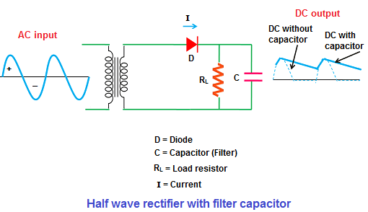
Full Wave Rectifier:
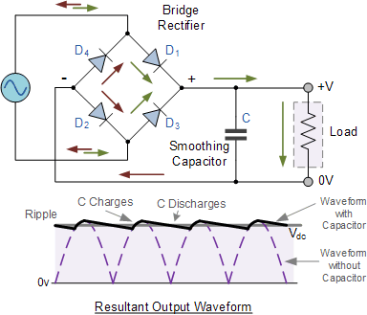
Theory:-
All Electronic circuit need a DC power supply for their operation. Rectifier is used to obtain the DC voltage from 230V AC mains. The rectifier is the device which converts AC voltage to DC voltage. The elements used for rectification is diode. Diode conducts only in one direction. When the diode is forward biased, it allows the current to flow through it.

Procedure:
1.Make the connections as per the circuit diagram(Excluding Capacitor).
2.Observe the input waveform on CRO.
3. Observe the waveform at secondary of the transformer.
4. Observe the waveform across load resister RL.

Conclusion:

