Assignment 3
Q.1) Solve the given circuit shown in figure & calculate its voltage gain, current gain, input
resistance & output resistance.
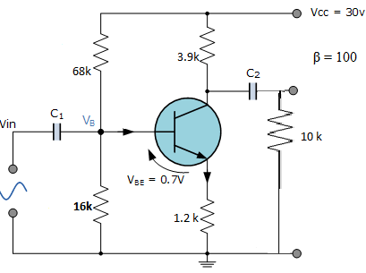
Q.2) Explain with the help of neat diagram the structure of a n- channel FET, and
Its volts amperes characteristics. In what ways it is different from BJT.
Q.3) Derive the expression for voltage gain, current gain, input resistance &
output resistance for common base amplifier circuit.
Q.4) Determine Z _{i} , Z_{o} & A_{v} for a circuit shown.
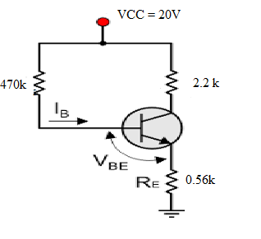
Q.5) Derive the expression for voltage gain, current gain, input resistance &
output resistance for NPN transistor in CE mode with R_{E} unbypassed.
Q.6 ) Draw & explain small signal hybrid pi model of BJT including early effect.
Q.7) Draw small signal model of JFET & explain significance of each parameter.
Q.8) Determine the small signal voltage gain & output resistance for a given
Circuit.
Q.9) Determine the small signal voltage gain, input resistance & output resistance
for a given circuit.
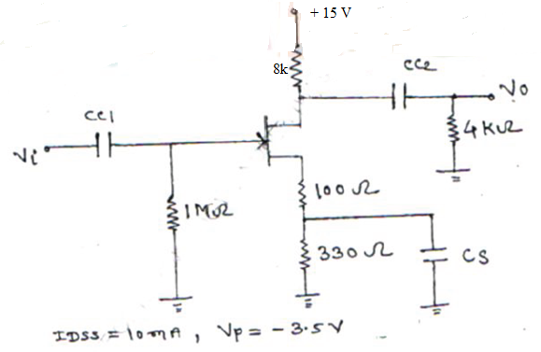
Q.10) Determine the small signal voltage gain, input resistance & output
resistance for common source amplifier unbypassed R_{S} circuit.

