Assignment No 2
Q.1) Calculate the Q-point values (IC and VCE) for this circuit
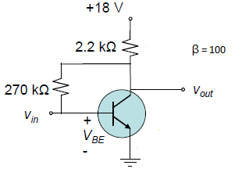
Q.2) For a given circuit, calculate the value of I_{D} & V_{DS} if V_{RS} = 1.5 V
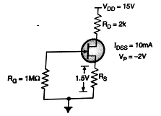
Q.3) Calculate the Q-point values (IC and VCE) for this circuit
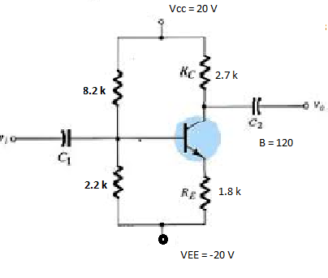
Q.4) Calculate the Q-point values (IC and VCE) for this circuit. (β = 100)
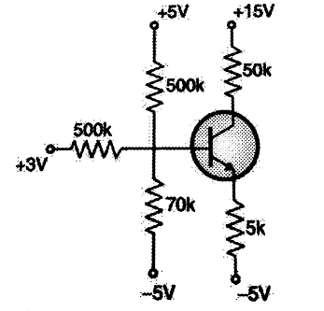
Q.5) Derive the condition for zero temperature drift of I_{DS} in FET.
Q.6) For the circuit shown, the transistor parameters are V _{p} = -3.5 V, I_{DSS} = 18 mA & λ = 0.
Calculate V_{GS} & V_{DS}.
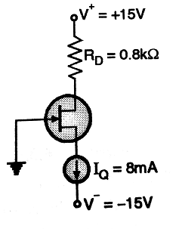
Q.7) For a given circuit, calculate the value of I_{D} & V_{DS}.
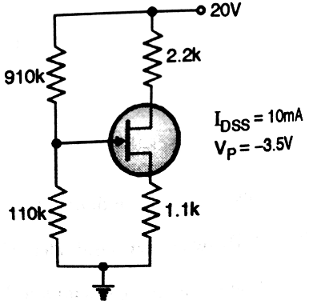
Q.8) For a given circuit, JFET parameters are I_{DSS} = 5 mA, V_{p} = -4 V.
Determine R_{D} ,R_{S},V_{D} ,V_{S}, V_{RD} if I_{D} = 2 mA & V_{DS} = 6 V.
