MODULE 4
INTRODUCTION TO CONTROL SYSTEM ANALYSIS

- Define open loop and closed loop systems with examples.
- Define feedback? What type of feedback is employed in control system?
- Why negative feedback is preferred in control systems?
- Define transfer function. What are the advantages and disadvantages of transfer Function?
- What is Impulse response of a system? If Impulse response of a certain system is e^{-5t}. Find out transfer function of this system.
- Compute the transfer function of the given Lead network
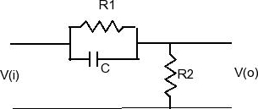
- Compute the transfer function of the given Lag network
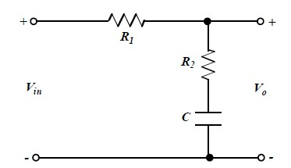
- Compute the transfer function of the given Lead-Lag network
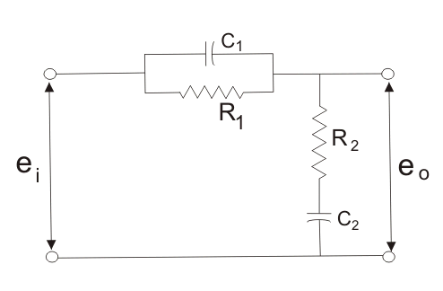
- Determine the overall transfer function C(S)/R(S) for the system shown in fig. (16) R(S)

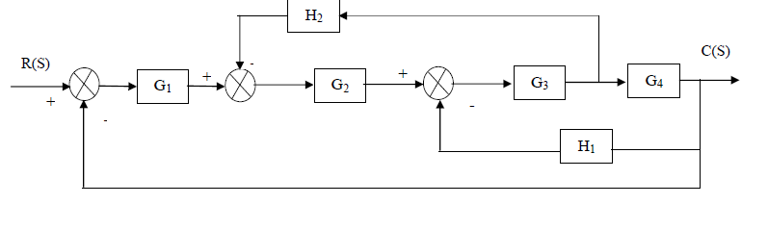
- Obtain the closed loop transfer function C(S)/R(S) of the system whose block diagram is shown in fig.
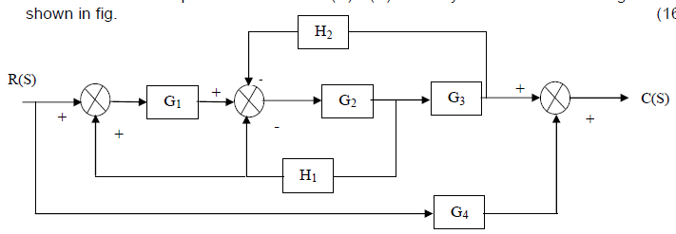

- For the system represented by the block diagram shown in fig. Determine C1/R1 and C2/R1.
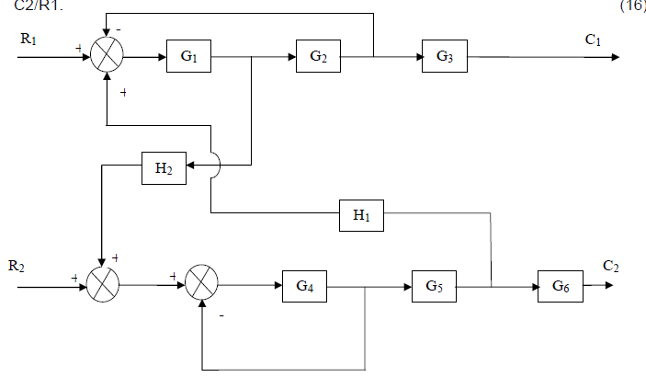
- Find the overall gain C(s) / R(s) for the signal flow graph shown below.
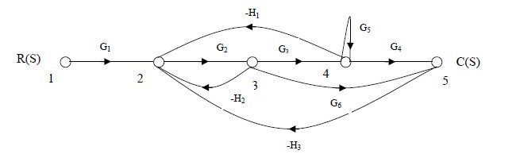
- Find the overall gain of the system whose signal flow graph is shown in fig.
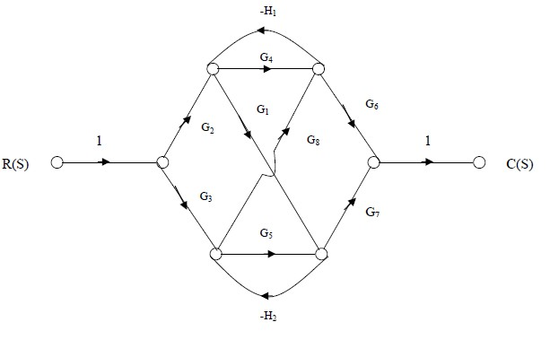
- Draw a signal flow graph and evaluate the closed loop transfer function of a system whose block is shown in fig.
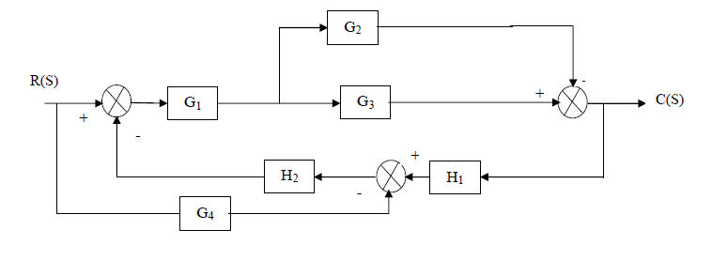
- Find the Transfer Function of the following Block diagrams
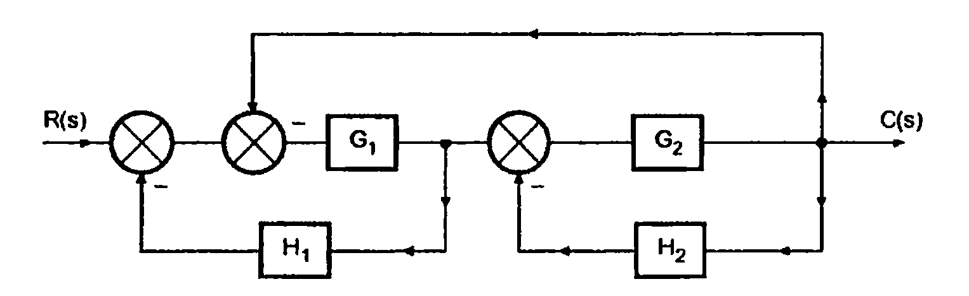

- Find the Transfer Function of the following Block diagrams

- Find the Transfer Function of the following Block diagrams

- Find the transfer function of the following block diagram
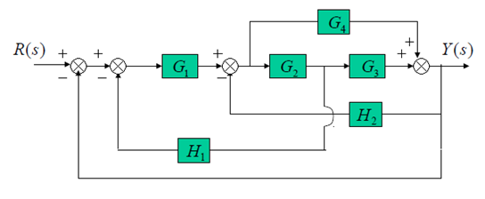
- Find the transfer function of the following signal flow graph using Mason’s Gain Formula
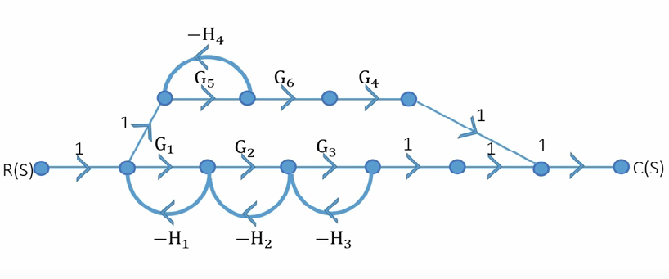
- Find the transfer function of the following signal flow graph using Mason’s Gain Formula

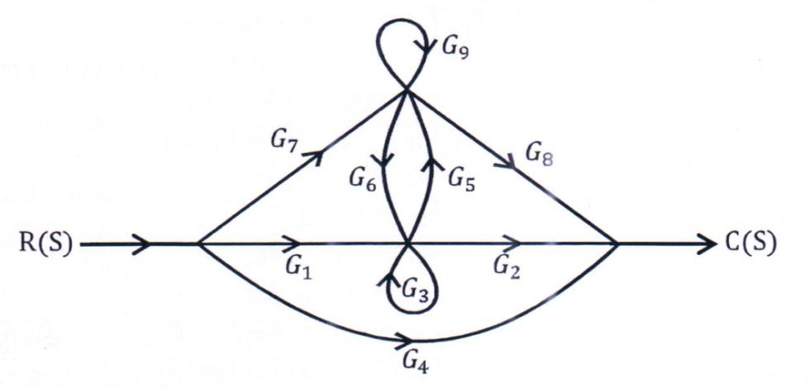
MODULE 5
STABILITY ANALYSIS IN TIME DOMAIN

- What is meant by type and order of the system?
- What is meant by steady state error?
- What are the various static error constants? How are they related to system steady state error?
- Define rise time, peak time, maximum overshoot, Delay time, Settling time
- Name the test signals used in time response analysis.
- (a) Derive the expressions and draw the response of first order system for unit step input.
(b) Draw the response of second order system for critically damped case and when input is unit step.
- Derive the expressions for Rise time, Peak time, Peak overshoot, delay time.
- A positional control system with velocity feedback is shown in fig. What is the response of the system for unit step input.
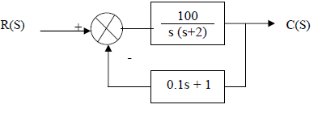
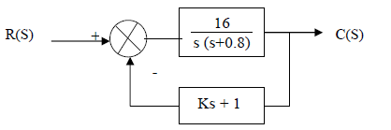
- A positional control system with velocity feedback is shown in fig. What is the response c (t) to the unit step input. Given that =0.5.and also calculate rise time, peak time, Maximum overshoot and settling time.
- For a unity feedback control system the open loop transfer function
G(S) = 10(S+2)/ S2 (S+1). Find
(a) Position, velocity and acceleration error constants.
(b) Steady state error when the input is R(S) where R(S) =3/S –2/S² +1/3S³
- The open loop transfer function of a servo system with unity feedback system is
G(S) = 10/ S (0.1S+1).
Evaluate the static error constants of the system. Obtain the steady state error of the system when subjected to an input given Polynomial r(t) = a₀ +a₁t +a₂ /2 t₂
- The unity feedback system is characterized by an open loop transfer function is
G(S) = K / S(S+10)
Determine the gain K, so that the system will have a damping ratio of 0.5.
For this value of K, determine settling time, Peak overshoot and time to Peak overshoot for a unit-step input.
- For a servomechanisms with open loop transfer function F(S) = 10/(S+2) (S+3).What type of input signal gives constant steady state error and calculate its value. Find the static error coefficients for a system whose G(S) H(S) =10/ S (1+S) (1+2S) and also find the steady state error for r (t) = 1+ t + t2/2.
- Use the Rouths stability criterion to determine the range of K for a unity feedback system whose open loop transfer function is
G(s) =$\frac{K}{s\left(s+1\right)\left(s+2\right)}$
- Using Routh’s stability criterion for a unity feedback system with open loop transfer function G(s) =$\frac{K}{s\left(s+1\right)\left(s+2\right)\left(s+5\right)}$ Find
  - Range of K for stability
  - Value of K for marginally stable
  - Actual location of closed loop poles when system is marginally stable.
- Sketch the root locus for the system with an open-loop transfer function given by
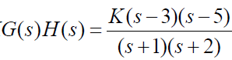

- Sketch the root locus for the system with an open-loop transfer function given by
- Sketch the root locus for the system with an open-loop transfer function given by
- For the system of the following figure, find the frequency and gain, K, for which the root locus crosses the imaginary axis. For what range of K is the system stable?

- Sketch the root locus for the system shown in figure and find the breakaway point on the real axis and the range of K within which the system is stable.

MODULE 6
STABILITY ANALYSIS IN FREQUENCY DOMAIN

- What is frequency response? List out the different frequency domain specifications.
- What is Bode plot? What are the main advantages of Bode plot?
- What are the three types of compensators? Explain uses of all three compensators.
- What does an octave line represent in a Bode plot?
- Define phase cross over frequency and gain cross over frequency.
- Define Phase margin and Gain margin of a system.
- Define resonant frequency, cut-off rate and bandwidth of a system.
- Plot the Bode diagram for the following transfer function and obtain the gain and phase cross over frequencies G(S) = 10/ S (1+0.4S) (1+0.1S)
- Sketch the Bode plot and hence find Gain cross over frequency, Phase cross over frequency, Gain margin and Phase margin G(S) = 0.75(1+0.2S)/ S(1+0.5S) (1+0.1S)
- Sketch the Bode plot and hence find Gain cross over frequency, Phase cross over frequency, Gain margin and Phase margin. G(S) = 10(S+3)/ S(S+2) (S2+4S+100)
- Plot the Bode diagram for the following transfer function and obtain the gain and phase cross over frequencies G(S) =KS2 / (1+0.2S) (1+0.02S). Determine the value of K for a gain cross over frequency of 20 rad/sec
- Plot the Bode diagram for the following transfer function and obtain the gain and phase cross over frequencies. G(S) = 10/ S (1+0.4S) (1+0.1S)
- The open loop transfer function of a unity feedback system is G(S) = 1/ S (1+S) (1+2S). Sketch the Polar plot and determine the Gain margin and Phase margin.
- Sketch the Bode plot and hence find Gain cross over frequency, Phase cross over frequency, Gain margin and Phase margin. G(S) = 0.75(1+0.2S)/ S (1+0.5S) (1+0.1S)
- Sketch the Bode plot and hence find Gain cross over frequency, Phase cross over frequency, Gain margin and Phase margin G(S) = 10(S+3)/ S(S+2) (S²+4S+100)
- Plot the Bode diagram for the following transfer function and obtain the gain and phase cross over frequencies G(S) =KS² / (1+0.2S) (1+0.02S). Determine the value of K for a gain cross over frequency of 20 rad/sec.
- Sketch the Nyquist diagram for the system shown in the following figure, and then determine the system stability using the Nyquist criterion.
- Draw the Nyquist plot for the system whose open loop transfer function is
G(S) H(S) =K/S (S+2) (S+10)
Determine the range of K for which closed loop system is stable.
- Construct Nyquist plot for a feedback control system whose open loop transfer function is given by G(S) H(S) =5/ S(1-S)
Comment on the stability of open loop and closed loop transfer function.
- Sketch the Nyquist plot for a system with the open loop transfer function
G(S) H(S) =K (1+0.5S) (1+S) / (1+10S) (S-1)
Determine the range of values of K for which the system is stable.

