TIME RESPONSE ANALYSIS

INTRODUCTION
It was stated previously in lecture #1 that the first step in analyzing a control system was to derive a mathematical model of the system. Once such a model is obtained, various methods are available for the analysis of system performance.
Typical Test Signals:
The commonly used test input signals are those of step functions, ramp functions, acceleration functions, impulse functions, sinusoidal functions, and the like. With these test signals, mathematical and experimental analyses of control systems can be carried out easily since the signals are very simple functions of time.
If the inputs to a control system are gradually changing functions of time, then a ramp function of time may be a good test signal. Similarly, if a system is subjected to sudden disturbances, a step function of time may be a good test signal; and for a system subjected to shock inputs, an impulse function may be best. Once a control system is designed on the basis of test signals, the performance of the system in response to actual inputs is generally satisfactory. The use of such test signals enables one to compare the performance of all systems on the same basis.
The time response of a control system consists of two parts as shown in Fig. 1;
  - Transient response
  - Steady-state response.
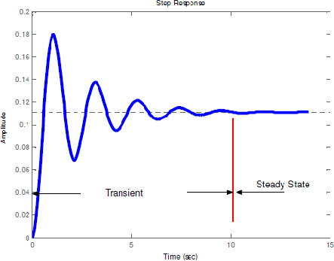
Fig. 1, Time response
By transient response, we mean that which goes from the initial state to the final state.
By steady-state response, we mean the manner in which the system output behaves as
t approaches infinity. Thus the system response C(t) may be written as
where C_{tr}(t) is the transient response and C_{ss}(t) is the steady-state response.
The transient response of a practical control system often exhibits damped oscillations before reaching a steady state. If the output of a system at steady state does not exactly agree with the input, the system is said to have steady state error. This error is indicative of the accuracy of the system. In analyzing a control system, we must examine transient-response behavior and steady-state behavior.

Transient Response
First-Order system
Consider the first-order system shown in Fig. 2.

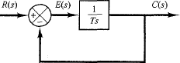
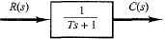
Fig. 2, Block diagram and simplification
The input-output relationship is given by
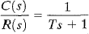

For a unit step input whose Laplace transform is 1/S, the output C(S) is given by

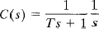
Using partial fraction,
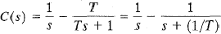

Taking the inverse Laplace transform

Above equation indicates initially (at t = 0) the output c(t) is zero and finally (at t = ∞) it becomes unity as shown in Fig. 3.

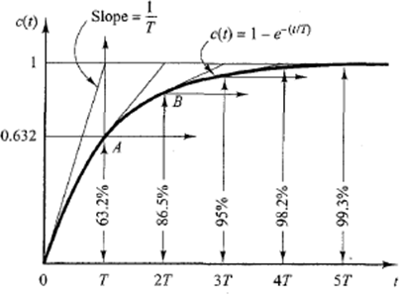
Fig.3. Time response of a first-order system

One important characteristic of such an exponential response curve c(t) is that at t = T the value of c(t) is 0.632, or the response c(t) has reached 63.2% of its final value. This may be easily seen by substituting t = T in c(t). That is,
By the same way, in two time constants (t = 2T), the response reaches 86.5% of the final value. At t = 3T, the response reaches 95% of its final value. At t = 4T, the system response reaches 98.2% of its final value. Finally at t = 5T, the response reaches 99.3% of the final value. Thus, for t ≥ 4T, the response remains within 2% of the final value. As seen from the equation of c(t), the steady state value (c(t) = 1) is reached mathematically only after an infinite time. In practice, however, a reasonable estimate of the response time is the length of time the response curve needs to reach and stay within the 2% line of the final value, or four time constants.

Second-Order Systems
Consider the 2nd order control system shown in Fig. 4, whose T.F. is given as:
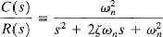

This form is called the standard form of the second-order system, where ζ and ω_{n} are the damping ratio and undamped natural frequency, respectively.
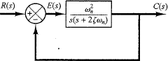
Fig.4. Standard form of Second-order control system
For a unit-step input ( R(S) = 1/S ), C(s) can be written
Using partial fraction,
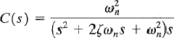

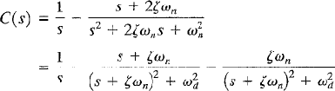

The frequency ω_{d}, is called the damped natural frequency.

Taking inverse Laplace for the output C(s),

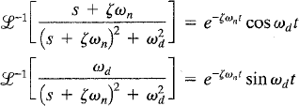
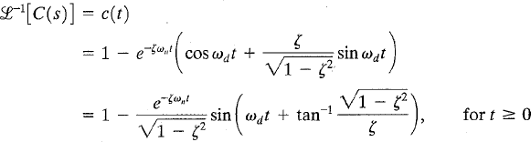
This result can be obtained directly by using a table of Laplace transforms tables.

If we plot the output C(t) versus time, such kind of plot is dependent on the two parameters ζ and ω_{n}. A family of curves at different values of ζ is shown in Fig. 5.
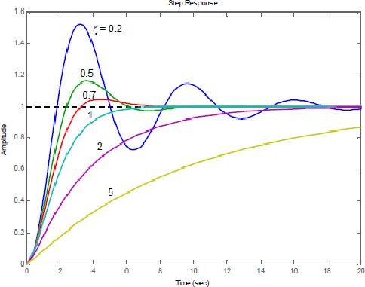
Fig. 5. Transient response of 2nd order system at different ζ.

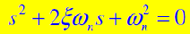
The characteristic equation of any 2nd order system is given by:
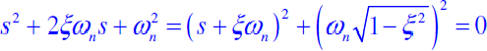

Complete square of the above equation we get;
As the parameters ζ changes, the location of the system poles S₁ and S₂ are change. Therefore, the dynamic behavior of the second-order system is also changes. The nature of the roots s₁ and s₂ of the characteristic equation with varying values of damping ratio ζ can be shown in the complex plane as shown in Fig. 6.
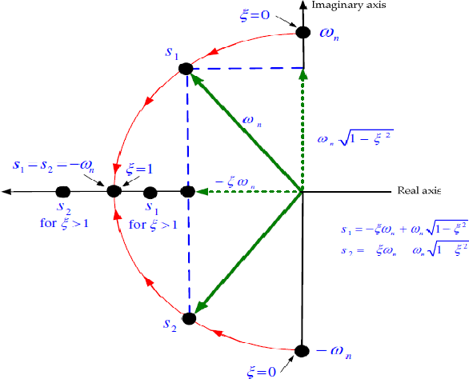

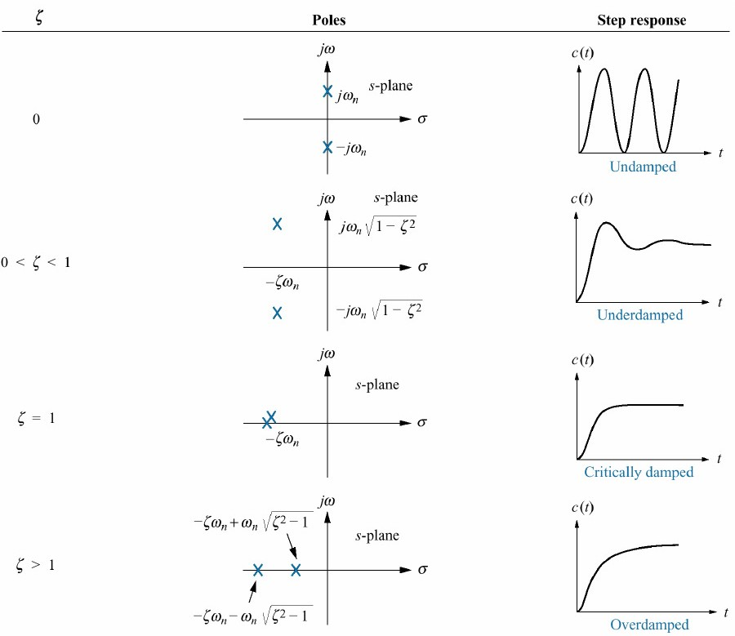

Fig.6 Closed loop poles and transient response

Transient Response Specifications

The transient response of a practical control system often exhibits damped oscillations before reaching a steady state. In specifying the transient‐response characteristics of a control system to a unit‐step input, it is common to name the following terms:
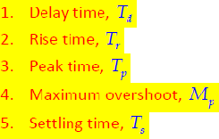
These specifications are shown graphically in Fig. 7.
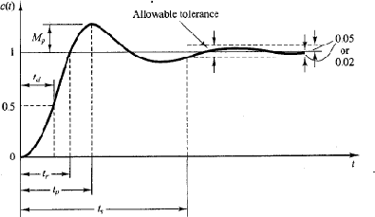
Fig. 7 Transient response specifications

Delay Time: The delay time t_{d} is the time needed for the response to reach half (50%) of its final value.
Delay time can be calculated from this formula;
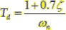
Rise Time: The rise time t_{r} is the time required for the response to rise from 10% to 90%. Or the time required to rise from 0% to 100% of its final value.
We obtain the rise time t_{r} by letting c(t_{r}) = 1
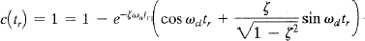
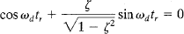

Since e–£ ^{m}ntr ≠ 0, therefore
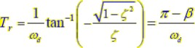

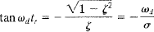
Where β is defined by Fig. 8, as the angle in radians.
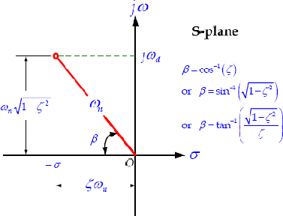
Fig.8. Definition of angle β

Peak Time: The peak time t_{p} is the time required for the response to reach the first peak of the overshoot.
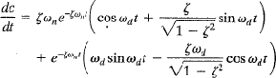
We may obtain the peak time by differentiating c(t) with respect to time and letting this derivative equal zero.

The cosine terms in the above equation cancel each other. Therefore, dc(t)/dt, evaluated at t = t_{p}, can be simplified to

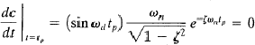

This means
Since the peak time corresponds to the first peak overshoot, md tp = n
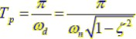
Maximum (percent Overshoot): The maximum percent overshoot M_{p} is the maximum peak value of the response curve [the curve of c(t) versus t ], measured from c (∞) . If c (∞) =1, the maximum percent overshoot is M_{p} × 100%. If the final steady state value c (∞) of the response differs from unity, then it is common practice to use the following definition:
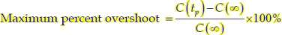
The maximum overshoot occurs at the peak time. Therefore
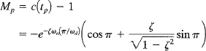

Mp = e
n £
–
ƒ1– £2

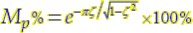

Settling Time: The settling time t_{s} is the time required for the response curve to reach and stay within ± 2% of the final value. In some cases, 5% instead of 2%, is used as the percentage of the final value. The settling time is the largest time constant of the system.
The settling time corresponding to ± 2% or ± 5% tolerance band may be measured in terms of the time constant {T = l/ (ζ ω_{n})}

Based on 2% criteria, it is found that T_{s} = 4T
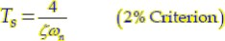
Based on 5% criteria, it is found that T_{s} = 3T
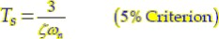

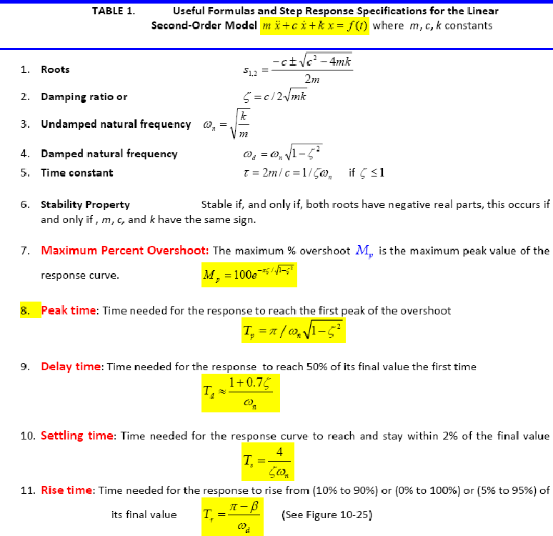
Summary:

Example #1
Consider the system shown in Fig. 9, where ζ = 0.6 and ω_{n} = 5 rad/sec. Let us obtain the rise time t_{r}, peak time t_{p}, maximum overshoot M_{p}, and settling time t_{p} when the system is subjected to a unit-step input.
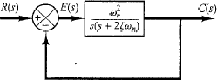
Fig. 9.
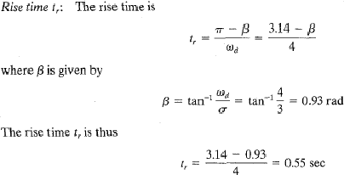
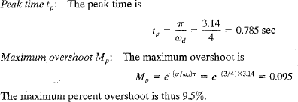
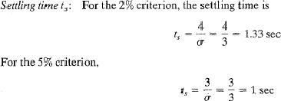

Example #2
Consider the control system whose closed loop poles are given in Fig. 10.
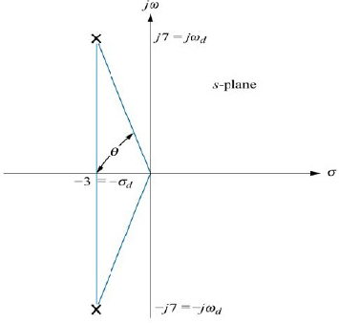
Fig. 10.
Find
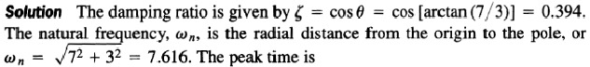
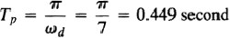
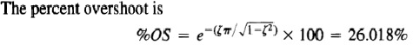
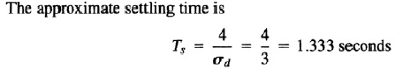

Example #3
Determine the values of T_{d}, T_{r}, T_{p} and T_{s} for the control system shown in Fig. 11.
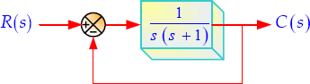

Fig. 11
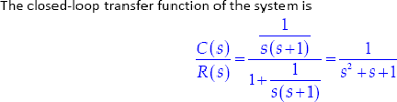
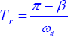
The rise time is given by
So we must calculate the angle β first based on Fig. 12, as follows:

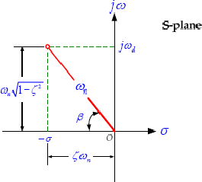
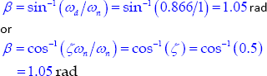

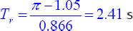

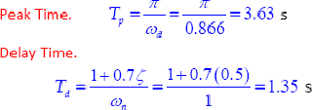
Fig. 12

