SYSTEM
A system is a combination or an arrangement of different physical components which act together to achieve certain objective.

CONTROL SYSTEM
A control system is a system of devices or set of devices that manages, commands, directs or regulates the behavior of other device(s) or system(s) to achieve desire results. A control system is a system, which controls other system.

REQUIREMENT OF GOOD CONTROL SYSTEM
Accuracy: Accuracy is the measurement tolerance of the instrument and defines the limits of the errors made when the instrument is used in normal operating conditions. Accuracy can be improved by using feedback elements. To increase accuracy of any control system error detector should be present in control system.
Sensitivity: The parameters of control system are always changing with change in surrounding conditions, internal disturbance or any other parameters. This change can be expressed in terms of sensitivity. Any control system should be insensitive to such parameters but sensitive to input signals only.
Noise: An undesired input signal is known as noise. A good control system should be able to reduce the noise effect for better performance.
Stability: It is an important characteristic of control system. For the bounded input signal, the output must be bounded and if input is zero then output must be zero then such a control system is said to be stable system.
Bandwidth: An operating frequency range decides the bandwidth of control system. Bandwidth should be large as possible for frequency response of good control system.
Speed: It is the time taken by control system to achieve its stable output. A good control system possesses high speed. The transient period for such system is very small.
Oscillation: A small numbers of oscillation or constant oscillation of output tend to system to be stable.

TYPES OF CONTROL SYSTEMS
There are various types of control system but all of them are created to control outputs. The system used for controlling the position, velocity, acceleration, temperature, pressure, voltage and current etc. are examples of control systems.
Let us take an example of simple temperature controller of the room, to clear the concept. Suppose there is a simple heating element, which is heated up as long as the electric power supply is switched on. As long as the power supply switch of the heater is on the temperature of the room rises and after achieving the desired temperature of the room, the power supply is switched off. Again due to ambient temperature, the room temperature falls and then manually the heater element is switched on to achieve the desired room temperature again. In this way one can manually control the room temperature at desired level. This is an example of manual control system. This system can further be improved by using timer switching arrangement of the power supply where the supply to the heating element is switched on and off in a predetermined interval to achieve desired temperature level of the room. There is another improved way of controlling the temperature of the room. Here one sensor measures the difference between actual temperature and desired temperature. If there is any difference between them, the heating element functions to reduce the difference and when the difference becomes lower than a predetermined level, the heating elements stop functioning. Both forms of the system are automatic control system. In former one the input of the system is entirely independent of the output of the system. Temperature of the room (output) increases as long as the power supply switch is kept on. That means heating element produces heat as long as the power supply is kept on and final room temperature does not have any control to the input power supply of the system. This system is referred as open loop control system. But in the later case, the heating elements of the system function, depending upon the difference between, actual temperature and desired temperature. This difference is called error of the system. This error signal is fed back to the system to control the input. As the input to output path and the error feedback path create a closed loop, this type of control system is referred as closed loop control system. Hence, there are two main types of control system. They are as follow
- Open loop control system
- Closed loop control system

OPEN LOOP CONTROL SYSTEM
A control system in which the control action is totally independent of output of the system then it is called open loop control system. Manual control system is also an open loop control system. Fig - 1 shows the block diagram of open loop control system in which process output is totally independent of controller action.
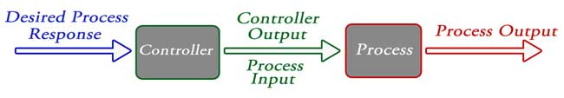

Practical Examples of Open Loop Control System
- Electric Hand Drier - Hot air (output) comes out as long as you keep your hand under the machine, irrespective of how much your hand is dried.
- Automatic Washing Machine - This machine runs according to the pre-set time irrespective of washing is completed or not.
- Bread Toaster - This machine runs as per adjusted time irrespective of toasting is completed or not.
- Automatic Tea/Coffee Maker - These machines also function for pre adjusted time only.
- Timer Based Clothes Drier - This machine dries wet clothes for pre-adjusted time, it does not matter how much the clothes are dried.
- Light Switch - Lamps glow whenever light switch is on irrespective of light is required or not.
- Volume on Stereo System - Volume is adjusted manually irrespective of output volume level.

Advantages of Open Loop Control System
- Simple in construction and design.
- Economical.
- Easy to maintain.
- Generally stable.
- Convenient to use as output is difficult to measure.

Disadvantages of Open Loop Control System
- They are inaccurate.
- They are unreliable.
- Any change in output cannot be corrected automatically.

CLOSED LOOP CONTROL SYSTEM
Control system in which the output has an effect on the input quantity in such a manner that the input quantity will adjust itself based on the output generated is called closed loop control system. Open loop control system can be converted in to closed loop control system by providing a feedback. This feedback automatically makes the suitable changes in the output due to external disturbance. In this way closed loop control system is called automatic control system. Figure below shows the block diagram of closed loop control system in which feedback is taken from output and fed in to input.

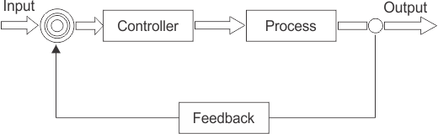

Practical Examples of Closed Loop Control System
- Automatic Electric Iron - Heating elements are controlled by output temperature of the iron.
- Servo Voltage Stabilizer - Voltage controller operates depending upon output voltage of the system.
- Water Level Controller - Input water is controlled by water level of the reservoir.
- Missile Launched and Auto Tracked by Radar - The direction of missile is controlled by comparing the target and position of the missile.
- An Air Conditioner - An air conditioner functions depending upon the temperature of the room.
- Cooling System in Car - It operates depending upon the temperature which it controls.

Advantages of Closed Loop Control System
- Closed loop control systems are more accurate even in the presence of non-linearity.
- Highly accurate as any error arising is corrected due to presence of feedback signal.
- Bandwidth range is large.
- Facilitates automation.
- The sensitivity of system may be made small to make system more stable.
- This system is less affected by noise.

Disadvantages of Closed Loop Control System
- They are costlier.
- They are complicated to design.
- Required more maintenance.
- Feedback leads to oscillatory response.
- Overall gain is reduced due to presence of feedback.
- Stability is the major problem and more care is needed to design a stable closed loop system.

Comparison of Closed Loop and Open Loop Control System

Sr. No. | Open loop control system | Closed loop control system
1 | The feedback element is absent. | The feedback element is always present.
2 | An error detector is not present. | An error detector is always present.
3 | It is stable one. | It may become unstable.
4 | Easy to construct. | Complicated construction.
5 | It is an economical. | It is costly.
6 | Having small bandwidth. | Having large bandwidth.
7 | It is inaccurate. | It is accurate.
8 | Less maintenance. | More maintenance.
9 | It is unreliable. | It is reliable.
10 | Examples: Hand drier, tea maker | Examples: Servo voltage stabilizer, perspiration

CONTROL SYSTEM
Control System means any quantity of interest in a machine or mechanism is accordance with desired manner A system which controls the output is called a control system.
The general block diagram of a control system is shown below.
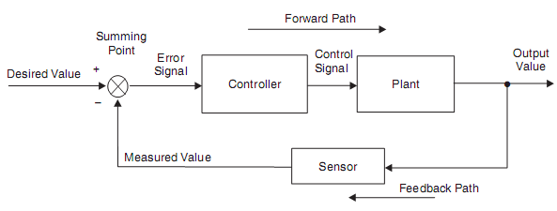
Figure: Closed-loop control system
Some Definitions
Reference input – It is the actual signal input to the control system.
Output (Controlled variable) – It is the actual response obtained from a control system.
Actuating error signal – It is the difference between the reference input and feedback signal.
Controller – It is a component required to generate control signal to drive the actuator.
Control signal – The signal obtained at the output of a controller is called control signal.
Actuator – It is a power device that produces input to the plant according to the control signal, so that output signal approaches the reference input signal.
Plant – The combination of object to be controlled and the actuator is called the plant.
Feedback Element – It is the element that provides a mean for feeding back the output quantity in order to compare it with the reference input.
Servomechanism – It is a feedback control system in which the output is mechanical position, velocity, or acceleration.

DEFINITIONS:
- Controlled Variable: It is the quantity or condition that is measured & controlled
- Controller: Controller means measuring the value of the controlled variable of the system & applying the manipulated variable to the system to correct or to limit the deviation of the measured value to the desired value.
- Plant: A plant is a piece of equipment, which is a set of machine parts functioning together. The purpose of which is to perform a particular operation.
Example: Furnace, Space craft etc.,
- System: A system is a combination of components that works together & performs certain objective.
- Disturbance: A disturbance is a signal that tends to affect the value of the output of a system. If disturbances created inside the system, it is called internal While an external disturbance is generated outside the system.
- Feedback Control: It is an operation that, in the presence of disturbance tends to reduce the difference between the output of a system & some reference input.
- Servo Mechanism: servo mechanism is a feedback controlled system in which the output is some mechanical position, velocity or acceleration.
- Open loop System: In an Open loop System, the control action is independent of the desired output.
- When the output quantity of the control system is not fed back to the input quantity, the control system is called an Open loop System.
- Closed loop System: In the Closed loop Control System the control action is dependent on the desired output, where the output quantity is considerably controlled by sending a command signal to input quantity

CLASSIFICATION OF CONTROL SYSTEMS
The Control System can be classified mainly depending upon,
- Method of analysis & design, as Linear & Non- Linear Systems.
- The type of the signal, as Time Varying, Time Invariant, Continuous data, Discrete data systems etc.
- The type of system components, as Electro Mechanical, Hydraulic, Thermal, Pneumatic Control systems etc.

The main purpose, as Position control & Velocity control Systems. Control systems are used to enhance production, efficiency and safety in many areas, including:
- Agriculture
- Chemical plants
- Pulp and paper mills
- Quality control
- Boiler controls and power plant
- Nuclear power plants
- Environmental control
- Water treatment plants
- Sewage treatment plants
- Food and food processing
- Metal and mines
- Pharmaceutical manufacturing
- Sugar refining plants

Feedback Loop of Control System

A feedback is a common and powerful tool when designing a control system. Feedback loop is the tool which take the system output into consideration and enables the system to adjust its performance to meet a desired result of system. In any control system, output is affected due to change in environmental condition or any kind of disturbance. So one signal is taken from output and is fed back to the input. This signal is compared with reference input and then error signal is generated. This error signal is applied to controller and output is corrected. Such a system is called feedback system. Figure below shows the block diagram of feedback system.

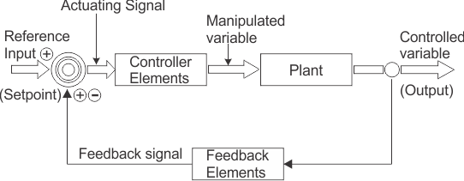
When feedback signal is positive then system called positive feedback system. For positive feedback system, the error signal is the addition of reference input signal and feedback signal. When feedback signal is negative then system is called negative feedback system. For negative feedback system, the error signal is given by difference of reference input signal and feedback signal.

Effect of Feedback
Refer figure beside, which represents feedback system where R = Input signal E = Error signal G = Forward path gain H = Feedback C = Output signal B = Feedback signal 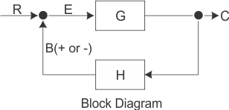
- Error between system input and system output is reduced.
- System gain is reduced by a factor 1/(1±GH).
- Improvement in sensitivity.
- Stability may be affected.
- Improve the speed of response.

There are two main types of control loops: Open loops, which operate with human input, and closed loops, which are fully autonomous. Some loops can be switched between closed and open modes. When open, a switchable loop is manually controlled and when closed it is fully automated.

