MODULE 4

SYSTEM: A system is a combination of components that act together and perform a certain objective. The system may be physical, biological, economical, etc.
CONTROL SYSTEM: It is an arrangement of physical components connected or related in a manner to command, direct or regulate itself or another system or is that means by which any quantity of interest in a system is maintained or altered in accordance with a desired manner.
Any control system consists of three essential components namely input, system and output. The input is the stimulus or excitation applied to a system from an external energy source. A system is the arrangement of physical components and output is the actual response obtained from the system.
The control system may be one of the following types
- man made
- natural and / or biological and
- hybrid consisting of man- made and natural or biological.
Examples:
An electric switch is man-made control system, controlling flow of electricity.
- input: flipping the switch on/off
- system: electric switch
- output: flow or no flow of current
Pointing a finger at an object is a biological control system.
- input: direction of the object with respect to some direction
- system: consists of eyes, arm, hand, finger and brain of a man
- output: actual pointed direction with respect to same direction
Man driving an automobile is a hybrid system.
- input: direction or lane
- system: drivers hand, eyes, brain and vehicle
- output: heading of the automobile.

CLASSIFICATION OF CONTROL SYSTEMS
Based on some parameters, we can classify the control systems into the following ways.

Continuous time and Discrete-time Control Systems
- Control Systems can be classified as continuous time control systems and discrete time control systems based on the type of the signal used.
- In continuous time control systems, all the signals are continuous in time. But, in discrete time control systems, there exists one or more discrete time signals.

SISO and MIMO Control Systems
- Control Systems can be classified as SISO control systems and MIMO control systems based on the number of inputs and outputs present.
- SISO (Single Input and Single Output) control systems have one input and one output. Whereas, MIMO (Multiple Inputs and Multiple Outputs) control systems have more than one input and more than one output

OPEN LOOP AND CLOSED LOOP CONTROL SYSTEMS
Control Systems can be classified as open loop control systems and closed loop control systems based on the feedback path.
OPEN LOOP CONTROL SYSTEMS
In open loop control systems, output is not fed-back to the input. So, the control action is independent of the desired output.
The following figure shows the block diagram of the open loop control system.
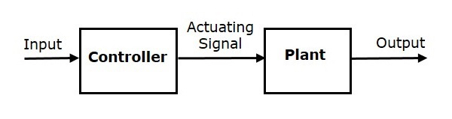
Here, an input is applied to a controller and it produces an actuating signal or controlling signal. This signal is given as an input to a plant or process which is to be controlled. So, the plant produces an output, which is controlled. The traffic lights control system which we discussed earlier is an example of an open loop control system.
EXAMPLE - 1 Rotational Generator
The input to rotational generator is the speed of the prime mover ( e.g steam turbine) in r.p.m. Assuming the generator is on no load the output may be induced voltage at the output terminals.
EXAMPLE – 2 Washing Machine
Most ( but not all ) washing machines are operated in the following manner. After the clothes to be washed have been put into the machine, the soap or detergent, bleach and water are entered in proper amounts as specified by the manufacturer. The washing time is then set on a timer and the washer is energized. When the cycle is completed, the machine shuts itself off. In this example washing time forms input and cleanliness of the clothes is identified as output.
EXAMPLE – 3 WATER TANK LEVEL CONTROL
To understand the concept further it is useful to consider an example let it be desired to maintain the actual water level 'c ' in the tank as close as possible to a desired level ' r '. The desired level will be called the system input, and the actual level the controlled variable or system output. Water flows from the tank via a valve V_{o} , and enters the tank from a supply via a control valve
V_{c.} The control valve is adjustable manually.

CLOSED LOOP CONTROL SYSTEMS
In closed loop control systems, output is fed back to the input. So, the control action is dependent on the desired output.
The following figure shows the block diagram of negative feedback closed loop control system.
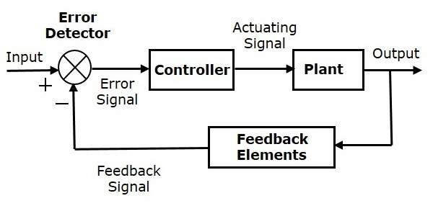
The error detector produces an error signal, which is the difference between the input and the feedback signal. This feedback signal is obtained from the block (feedback elements) by considering the output of the overall system as an input to this block. Instead of the direct input, the error signal is applied as an input to a controller.
So, the controller produces an actuating signal which controls the plant. In this combination, the output of the control system is adjusted automatically till we get the desired response. Hence, the closed loop control systems are also called the automatic control systems. Traffic lights control system having sensor at the input is an example of a closed loop control system.
EXAMPLE – 1 – THERMAL SYSTEM
To illustrate the concept of closed loop control system, consider the thermal system shown in fig- 6. Here human being acts as a controller. He wants to maintain the temperature of the hot water at a given value rº C. the thermometer installed in the hot water outlet measures the actual temperature C⁰ C. This temperature is the output of the system. If the operator watches the thermometer and finds that the temperature is higher than the desired value, then he reduce the amount of steam supply in order to lower the temperature. It is quite possible that that if the temperature becomes lower than the desired value it becomes necessary to increase the amount of steam supply. This control action is based on closed loop operation which involves human being, hand muscle, eyes, thermometer such a system may be called manual feed back system.

EXAMPLE –2 HOME HEATING SYSTEM
The thermostatic temperature control in hour homes and public buildings is a familiar example. An electronic thermostat or temperature sensor is placed in a central location usually on inside wall about 5 feet from the floor. A person selects and adjusts the desired room temperature ( r ) say 25⁰ C and adjusts the temperature setting on the thermostat. A bimetallic coil in the thermostat is affected by the actual room temperature ( c ). If the room temperature is lower than the desired temperature the coil strip alters the shape and causes a mercury switch to operate a relay, which in turn activates the furnace fire when the temperature in the furnace air duct system reaches reference level ' r ' a blower fan is activated by another relay to force the warm air throughout the building. When the room temperature ' C ' reaches the desired temperature ' r ' the shape of the coil strip in the thermostat alters so that Mercury switch opens. This deactivates the relay and in turn turns off furnace fire, which in turn the blower.
A change in out door temperature is a disturbance to the home heating system. If the out side temperature falls, the room temperature will likewise tend to decrease.

The differences between the open loop and the closed loop control systems are mentioned in the following table.
Open Loop Control Systems | Closed Loop Control Systems
Control action is independent of the desired output. | Control action is dependent of the desired output.
Feedback path is not present. | Feedback path is present.
These are also called as non-feedback control systems. | These are also called as feedback control systems.
Easy to design. | Difficult to design.
These are economical. | These are costlier.
Inaccurate. | Accurate.

DEFINITIONS:
System: A system is a combination of components that act together and perform a certain objective. The system may be physical, biological, economical, etc.
Control system: It is an arrangement of physical components connected or related in a manner to command, direct or regulate itself or another system.
Open loop: An open loop system control system is one in which the control action is independent of the output.
Closed loop: A closed loop control system is one in which the control action is somehow dependent on the output.
Plants: A plant is equipment the purpose of which is to perform a particular operation. Any physical object to be controlled is called a plant.
Processes: Processes is a natural or artificial or voluntary operation that consists of a series of controlled actions, directed towards a result.
Input: The input is the excitation applied to a control system from an external energy source.
The inputs are also known as actuating signals.
Output: The output is the response obtained from a control system or known as controlled variable.
Block diagram: A block diagram is a short hand, pictorial representation of cause and effect relationship between the input and the output of a physical system. It characterizes the functional relationship amongst the components of a control system.
Control elements: These are also called controller which are the components required to generate the appropriate control signal applied to the plant.
Plant: Plant is the control system body process or machine of which a particular quantity or condition is to be controlled.
Feedback control: feedback control is an operation in which the difference between the output of the system and the reference input by comparing these using the difference as a means of control.
Feedback elements: These are the components required to establish the functional relationship between primary feedback signal and the controlled output.
Actuating signal: also called the error or control action. It is the algebraic sum consisting of reference input and primary feedback.
Manipulated variable: it that quantity or condition which the control elements apply to the controlled system.
Feedback signal: it is a signal which is function of controlled output
Disturbance: It is an undesired input signal which affects the output.
Forward path: It is a transmission path from the actuating signal to controlled output
Feedback path: The feed back path is the transmission path from the controlled output to the primary feedback signal.
Servomechanism: Servomechanism is a feedback control system in which output is some mechanical position, velocity or acceleration.
Regulator: Regulator is a feedback system in which the input is constant for long time.
Transducer: Transducer is a device which converts one energy form into other
Tachometer: Tachometer is a device whose output is directly proportional to time rate of change of input.
Synchros: Synchros is an AC machine used for transmission of angular position synchro motor- receiver, synchro generator- transmitter.

