BLOCK DIAGRAM REDUCTION RULES

DEFINITION:
A block diagram of a system is a pictorial representation of the functions performed by each component of the system and shows the flow of signals. In block diagram, the system consists of so many components. These components are linked together to perform a particular function. Each component can be represented with the help of individual block.

NEED FOR BLOCK DIAGRAM REDUCTION:
Block diagrams of some of the systems turn out to be complex, such that the evaluation of their performance required simplification (or reduction) of block diagrams which is carried out by block diagram rearrangements.

ADVANTAGES OF BLOCK DIAGRAM:
- Very simple to construct the block diagram for complicated systems.
- Individual as well as overall performance of the system can be studied by using transfer functions shown in the block diagram.
- Overall closed loop transfer function can be easily calculated using block diagram rules.
- The function of the individual element can be visualized from the block diagram.

DISADVANTAGES OF BLOCK DIAGRAM:
- Block diagram does not include any information about the physical construction of the system.
- Source of energy is generally not shown in the block diagram, so block diagram for a given system is not unique.

The basic components of block diagram are block, branches, summing point, arrows.

BLOCK:
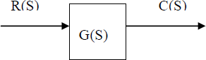
It indicates the function of particular system. R(s) is the reference or controlling variable. G(s) is the transfer function of the particular system.C(s) is output or controlled variable.

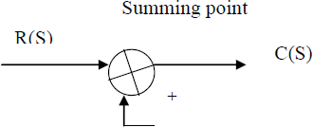
SUMMING POINT

TAKE OF POINT
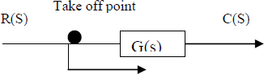

THE STEPS TO REDUCE THE BLOCK DIAGRAM
- Reduce the series blocks.
- Reduce the parallel blocks.
- Reduce minor feedback loops.
- As for as possible shift summing point to the left and take-off point to the right.
- Repeat the above steps till canonical form is obtained.

RULES FOR REDUCTION OF BLOCK DIAGRAM

Rule 1: If the blocks are in cascade then
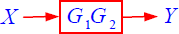
Rule 2: if the blocks are in parallel then, the blocks are added or subtracted depending on the summing point signal.
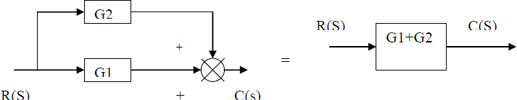
Rule 3: Moving the take-off point after the block

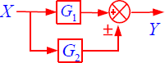
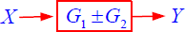

Rule 4: moving the take-off point after the block

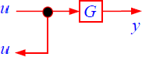
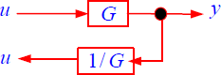
Rule 5: moving the take-off point before the block
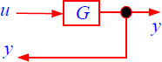
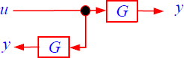

Rule 6: Moving summing point after the block
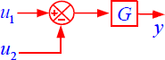
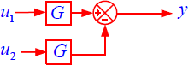

Rule 7: Moving the summing point ahead (before) the block off

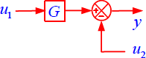
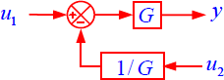

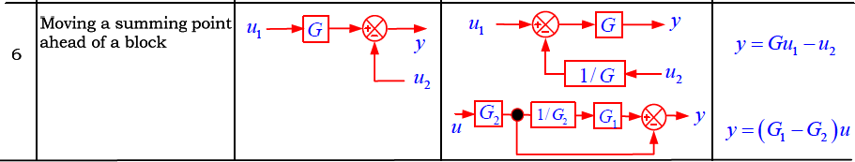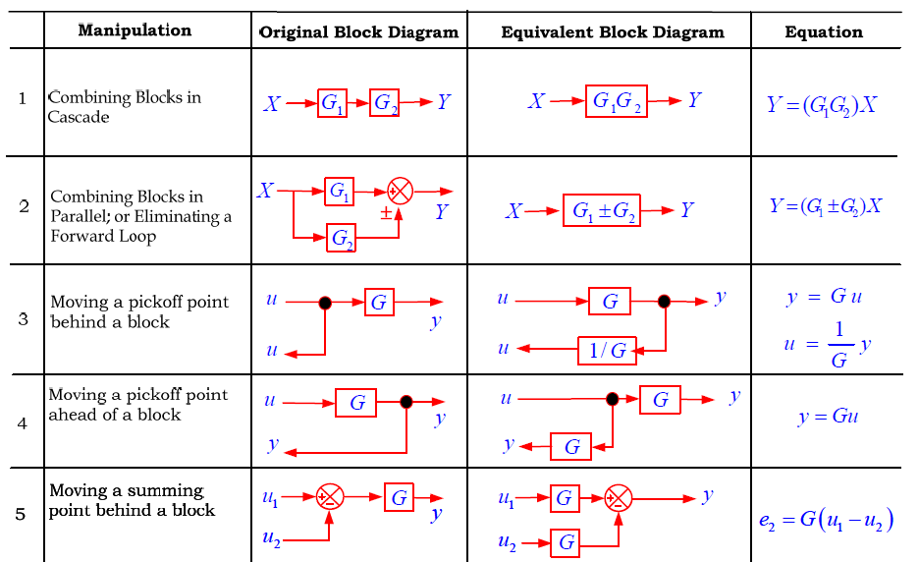

Ex: Using block diagram reduction technique find closed loop transfer function C(s) / R(s) shown in figure below:
a g e
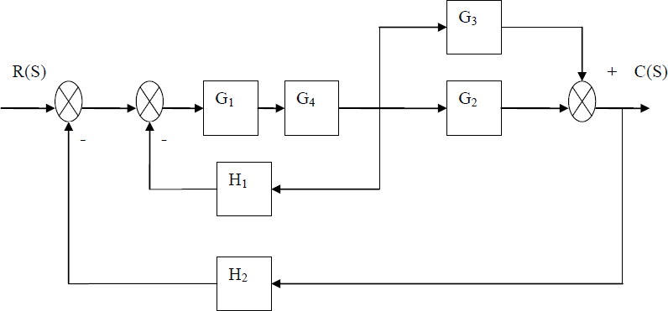

Step 1: Combine the blocks G1 &G2 which are in cascade and combine the blocks G2 &G3 which are in parallel
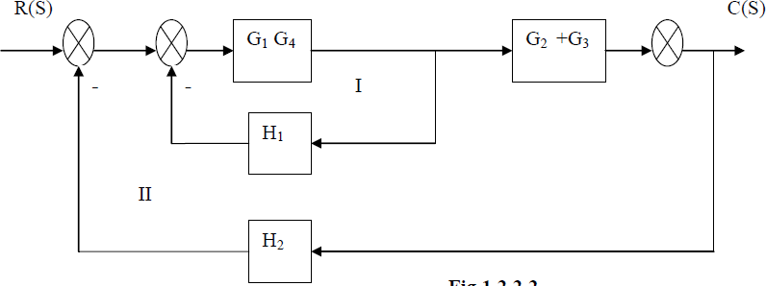

Step 2: Eliminate feedback loop I and combine the blocks (G1G4 / 1+ G1G4H1) & (G2 + G3) which are in parallel as shown
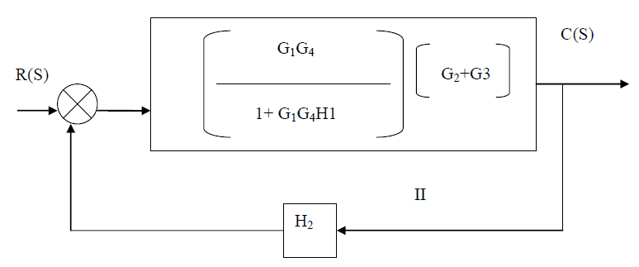

Step 3: eliminate feedback loop II

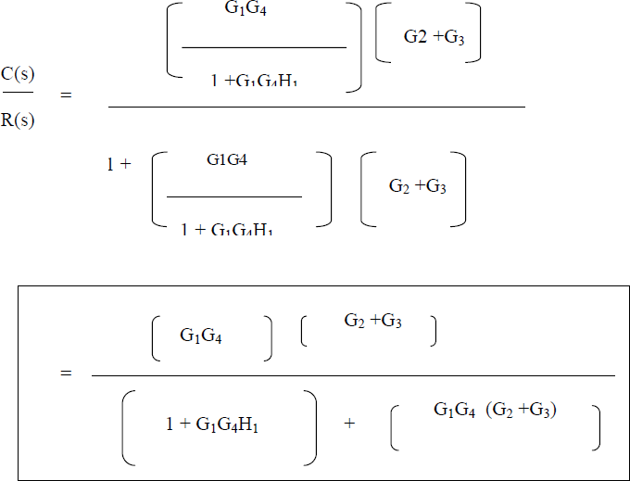

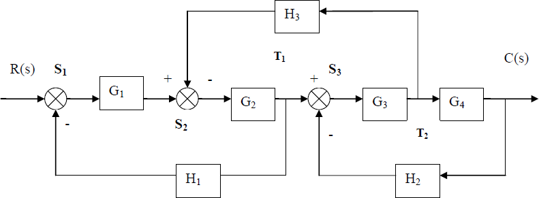
Ex: Determine the transfer function C(s) / R(s) of the system shown in Figure below by block diagram reduction method.

Step:1.

Shifting the summing point S2 before the block G1 and shifting the take off point T2 after the block G4.
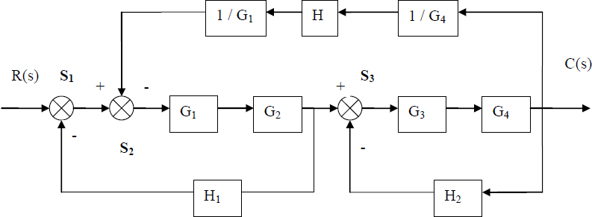

Step:2.

Exchange the summing points and take off points using associative law and combining the series blocks we get
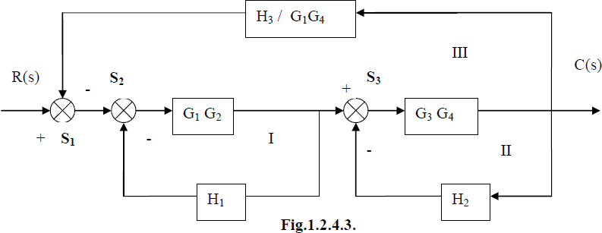

Step:3
Eliminating inner feedback loops I, II
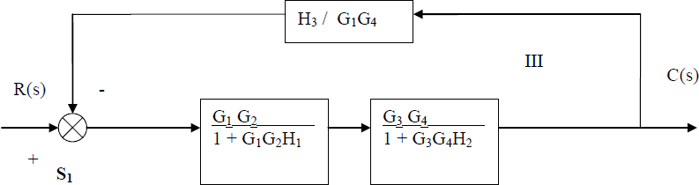

Step:4
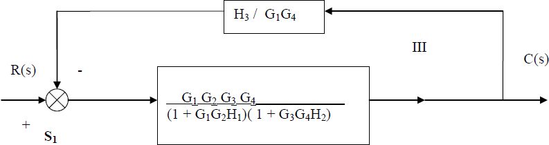
Combine the blocks in series

Step 5:
Eliminate the feedback loop III

