EXPERIMENT NO.: 8
AIM: To write a program to generate and plot OOK, BPSK and FSk signals using Python.
SOFTWARE USED: Python 3.5.1 (Anaconda3 2.5.0)
THEORY:
If the information signal is digital and the amplitude of the carrier is varied proportional to the information signal, a digitally modulated signal called amplitude shift keying (ASK) is produced. If the frequency (f) is varied proportional to the information signal, frequency shift keying (FSK) is produced, and if the phase of the carrier (0) is varied proportional to the information signal, phase shift keying (PSK) is produced. If both the amplitude and the phase are varied proportional to the information signal, quadrature amplitude modulation (QAM) results. ASK, FSK, PSK, and QAM are all forms of digital modulation:
AMPLITUDE-SHIFT KEYING
The simplest digital modulation technique is amplitude-shift keying (ASK), where a binary information signal directly modulates the amplitude of an analog carrier. ASK is similar to standard amplitude modulation except there are only two output amplitudes possible. Amplitudeshift keying is sometimes called digital amplitude modulation (DAM)
Mathematically, amplitude-shift keying is
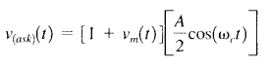
where Vask(t) = amplitude-shift keying wave
Vm(t) = digital information (modulating) signal (volts)
A/2 = unmodulated carrier amplitude (volts)
ωc = analog carrier radian frequency (radians per second, 2πfc t)
From the figure, it can be seen that for every change in the input binary data stream, there is one change in the ASK waveform, and the time of one bit (tb) equals the time of one analog signaling element (t,). B = fb /1 = fb baud = fb /1 = fb
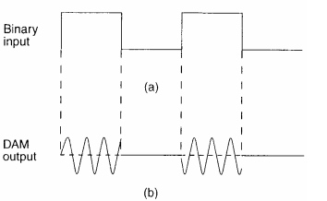
The entire time the binary input is high, the output is a constant amplitude, constant-frequency signal, and for the entire time the binary input is low, the carrier is off. The rate of change of the ASK waveform (baud) is the same as the rate of change of the binary input (bps).
FREQUENCY-SHIFT KEYING:
FSK is a form of constant-amplitude angle modulation similar to standard frequency modulation (FM) except the modulating signal is a binary signal that varies between two discrete voltage levels rather than a continuously changing analog waveform. Consequently, FSK is sometimes called binary FSK (BFSK). The general expression for FSK is
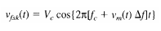
where Vfsk(t) = binary FSK waveform
Vc = peak analog carrier amplitude (volts)
fc = analog carrier center frequency (hertz)
∆f = peak change (shift) in the analog carrier frequency 11 (hertz)
vm(t) = binary input (modulating) signal (volts)
From Equation, it can be seen that the peak shift in the carrier frequency (∆f) is proportional to the amplitude of the binary input signal (vm[t]), and the direction of the shift is determined by the polarity.
With binary FSK, the carrier center frequency (fc) is shifted (deviated) up and down in the frequency domain by the binary input signal as shown in Figure.
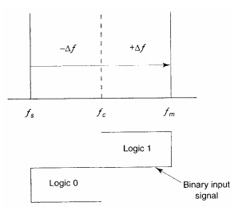
Figure below shows in the time domain the binary input to an FSK modulator and the corresponding FSK output. When the binary input (fb) changes from a logic 1 to a logic 0 and vice versa, the FSK output frequency shifts from a mark ( fm) to a space (fs) frequency and vice versa.
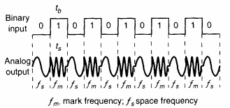
BINARY PHASE-SHIFT KEYING:
The simplest form of PSK is binary phase-shift keying (BPSK), where N = 1 and M = 2. Therefore, with BPSK, two phases (21 = 2) are possible for the carrier. One phase represents a logic 1, and the other phase represents a logic 0. As the input digital signal changes state (i.e., from a 1 to a 0 or from a 0 to a 1), the phase of the output carrier shifts between two angles that are separated by 180°. Hence, other names for BPSK are phase reversal keying (PRK) and biphase modulation. BPSK is a form of square-wave modulation of a continuous wave (CW) signal.
Mathematically, the output of a BPSK modulator is proportional to
BPSK output = [sin (2πfa t)] x [sin (2πfc t)]
where fa = maximum fundamental frequency of binary input (hertz)
fc = reference carrier frequency (hertz)
Figure below shows the output phase-versus-time relationship for a BPSK waveform. Logic 1 input produces an analog output signal with a 0° phase angle, and a logic 0 input produces an analog output signal with a 180° phase angle. 28 As the binary input shifts between a logic 1 and a logic 0 condition and vice versa, the phase of the BPSK waveform shifts between 0° and 180°, respectively. BPSK signaling element (ts) is equal to the time of one information bit (tb), which indicates that the bit rate equals the baud
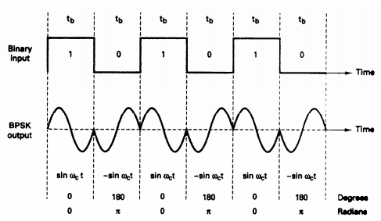

PROCEDURE:
- Include numpy and matplotlib libraries in the beginning.
- Use appropriate commands from the above libraries to perform the given task
- Observe the the output in console window.
- Plot the functions in new figure window.

CONCLUSION:

SAMPLE QUESTIONS:
- Comment on the spectrum for OOK.
- What is inter-symbol interference and how can we reduce ISI?
- Can we use non-linear amplifiers (class C or E) for PSK?

