EXPERIMENT NO.: 6
AIM: To design and program 2 - bit counter with structural modeling using VHDL and test the output using test bench.
SOFTWARE USED: ISE Design Suite 14.4
THEORY:
The name T flip-flop is termed from the nature of toggling operation. The major applications of T flip-flop are counters and control circuits. T flip flop is modified form of JK flip-flop making it to operate in toggling region.
Whenever the clock signal is LOW, the input is never going to affect the output state. The clock has to be high for the inputs to get active. Thus, T flip-flop is a controlled Bi-stable latch where the clock signal is the control signal. Thus, the output has two stable states based on the inputs which have been discussed below.
Truth Table of T Flip Flop:
Clock | INPUT |  | OUTPUT
Clock | RESET | T | Q | Q’
X | LOW | X | 0 | 1
HIGH | HIGH | 0 | No Change
HIGH | HIGH | 1 | Toggle
LOW | HIGH | X | No Change

The T flip flop is the modified form of JK flip flop. The Q and Q’ represents the output states of the flip-flop. According to the table, based on the input the output changes its state. But, the important thing to consider is all these can occur only in the presence of the clock signal. This, works unlike SR flip Flop & JK flip-flop for the complimentary inputs. This only has the toggling function.

RESET:
The RESET pin has to be active HIGH. All the pins will become inactive upon LOW at RESET pin. Hence, this pin always pulled up and can be pulled down only when needed.

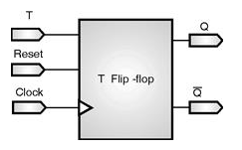
Figure shows a 2-bit counter designed using T flip-flop capable of counting from 0 to 3. The clock inputs of both the flip-flops are connected in cascade. The T input of each flip-flop is connected to a constant 1, which means that the state of the flip-flop will be toggled at each active edge (here, it is positive edge) of its clock. We assume that the purpose of this circuit is to count the number of pulses that occur on the primary input called Clock. Thus the clock input of the first flip-flop is connected to the Clock line. The other flip-flop has its clock inputs driven by the Q’ output of the preceding flip-flop. Therefore, they toggle their states whenever the preceding flip-flop changes its state from Q = 1 to Q = 0, which results in a positive edge of the Q signal. Here the value of the count is the indicated by the 2-bit binary number Q1Q0. The value of Q0 toggles once every clock cycle. The change takes place shortly after the positive edge of the Clock signal. The delay is caused by the propagation delay through the flip-flop. Since the second flip-flop is clocked by Q0, the value of Q1 changes shortly after the negative edge of the Q0 signal. Because it counts in the upward direction, we call it an up-counter.
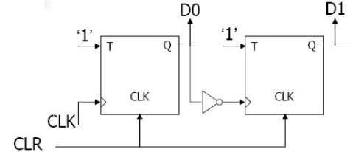

PROCEDURE:
- Open ISE 14.4 design suite.
- Create a new project with default chip setting and preferred language VHDL.
- Create a new module by selecting “New Source” and type of source as” VHDL Module”
- Create an entity for designing a T flip-flop according to given diagram.
- Define T flip-flop architecture with behavioral modeling using if-else statement.
- Save the changes and click “Behavioral Check Syntax” option from processes.
- Create a “New Source” again with type of source as “ VHDL Test Bench”.
- Describe the test bench for all combinations of inputs.
- Simulate the test bench and observe the output waveforms.
- Now create a new module by selecting “New Source” and type of source as” VHDL Module”
- Create an entity for designing a 2 – bit counter according to given diagram.
- Define 2 – bit counter architecture with structural modeling using T flip-flop as component.
- Save the changes and click “Behavioral Check Syntax” option from processes.
- Create a “New Source” again with type of source as “ VHDL Test Bench”.
- Describe the test bench for all combinations of inputs.
- Simulate the test bench and observe the output waveforms.
CONCLUSION:

SAMPLE QUESTIONS:
- What is the difference between variable and signal? Explain with example.
- What is the difference between entity and component declaration?

