EXPERIMENT NO.: 4
AIM: To design and program 8:1 MUX with behavioral modeling using VHDL and test the output using test bench.
SOFTWARE USED: ISE Design Suite 14.4
THEORY:
Multiplexer is simply a data selector.It has multiple inputs and one output.Any one of the input line is transferred to output depending on the control signal.This type of operation is usually referred as multiplexing .In 8:1 multiplexer ,there are 8 inputs.Any of these inputs are transferring to output ,which depends on the control signal.For 8 inputs we need ,3 bit wide control signal .
Working:If control signal is "000" ,then the first input is transferring to output line.If control signal is "111",then the last input is transferring to output.Similarly for all values of control signals.A simple block diagram of 8:1 multiplexer is shown here.
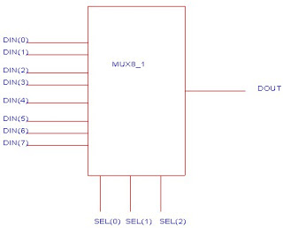
PROCEDURE:
- Open ISE 14.4 design suite.
- Create a new project with default chip setting and preferred language VHDL.
- Create a new module by selecting “New Source” and type of source as” VHDL Module”
- Create an entity according to given diagram.
- Define 8:1 MUX architecture with behavioral modeling using case statement.
- Save the changes and click “Behavioral Check Syntax” option from processes.
- Create a “New Source” again with type of source as “ VHDL Test Bench”.
- Describe the test bench for all combinations of inputs.
- Simulate the test bench and observe the output waveforms.
CONCLUSION:

SAMPLE QUESTIONS:
- What is the importance of writing a test bench for checking the circuit?
- What is the difference between concurrent and sequential statements?

