EXPERIMENT NO.: 3
AIM: To design and program 1-bit full adder using VHDL with dataflow modeling and test the output using test bench.
SOFTWARE USED: ISE Design Suite 14.4
THEORY:

Full Adder
The VHDL Code for full-adder circuit adds three one-bit binary numbers (A B Cin) and outputs two one-bit binary numbers, a sum (S) and a carry (Cout). Truth Table describes the functionality of full adder. sum(S) output is High when odd number of inputs are High. Cout is High, when two or more inputs are High. VHDL Code for full adder can also be constructed with 2 half adder Port mapping in to full adder.
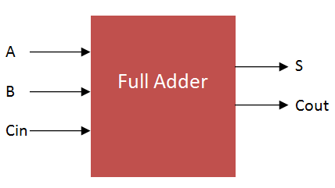

Full Adder Truth Table
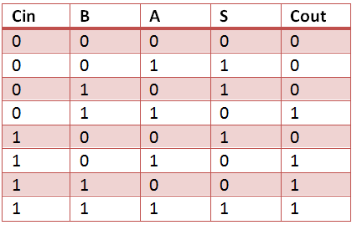
PROCEDURE:
- Open ISE 14.4 design suite.
- Create a new project with default chip setting and preferred language VHDL.
- Create a new module by selecting “New Source” and type of source as” VHDL Module”
- Create an entity according to given diagram.
- Define full adder architecture with dataflow modeling
- Save the changes and click “Behavioral Check Syntax” option from processes.
- Create a “New Source” again with type of source as “ VHDL Test Bench”.
- Describe the test bench for all combinations of inputs.
- Simulate the test bench and observe the output waveforms.
CONCLUSION:

SAMPLE QUESTIONS:
- What is VHDL?
- What can be various uses of VHDL?

