EXPERIMENT NO.: 3
AIM: To design and simulate band pass filter with center frequency 50 MHz using LTSpice.
SOFTWARE USED: LTSpice version IV
THEORY:
Unlike the low pass filter which only pass signals of a low frequency range or the high pass filter which pass signals of a higher frequency range, a Band Pass Filters passes signals within a certain “band” or “spread” of frequencies without distorting the input signal or introducing extra noise. This band of frequencies can be any width and is commonly known as the filters Bandwidth.
Bandwidth is commonly defined as the frequency range that exists between two specified frequency cut-off points ( ƒc ), that are 3dB below the maximum centre or resonant peak while attenuating or weakening the others outside of these two points.
Then for widely spread frequencies, we can simply define the term “bandwidth”, BW as being the difference between the lower cut-off frequency ( ƒc_{LOWER} ) and the higher cut-off frequency ( ƒc_{HIGHER} ) points. In other words, BW = ƒ_{H} – ƒ_{L}. Clearly for a pass band filter to function correctly, the cut-off frequency of the low pass filter must be higher than the cut-off frequency for the high pass filter.
The “ideal” Band Pass Filter can also be used to isolate or filter out certain frequencies that lie within a particular band of frequencies, for example, noise cancellation. Band pass filters are known generally as second-order filters, (two-pole) because they have “two” reactive component, the capacitors, within their circuit design. One capacitor in the low pass circuit and another capacitor in the high pass circuit.
Resonance occurs when an LC circuit is driven from an external source at an angular frequency ω₀ at which the inductive and capacitive reactances are equal in magnitude. The frequency at which this equality holds for the particular circuit is called the resonant frequency. The resonant frequency of the LC circuit is
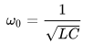
where L is the inductance in henrys, and C is the capacitance in farads. The angular frequency ω₀ has units of radians per second.
The equivalent frequency in units of hertz is
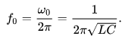

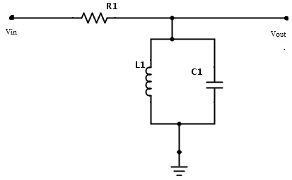
PROCEDURE:
- To simulate a band pass filter with center frequency 50 MHz in LTSpice, select proper values of inductor and capacitor from component toolbar.
- Connect the rest of the circuit according to given diagram with R1 = 1Kohm. Connect a load resistor R2 = 1Kohm. Use 1V AC sine wave source as Vin.
- Click “Run”, enter proper simulation conditions for a transient analysis and then click “OK”
- Measure the output voltage at “Vo” by connecting probe at the node.
- With same source re-simulate the circuit with proper simulation conditions for an ac analysis and then click “OK”.
- Measure the output voltage at “Vo” by connecting probe at the node.

CONCLUSION:

SAMPLE QUESTIONS:
- Calculate the gain of the filter.
- Which component will you change to change the center frequency to 60 MHz ? Simulate the circuit.
- Give applications of this type of filter.

