EXPERIMENT NO.: 2
AIM: To design and simulate single stage BJT amplifier with transistor BC547 using LTSpice.
SOFTWARE USED: LTSpice version IV
THEORY:
The single stage common emitter amplifier circuit shown above uses what is commonly called “Voltage Divider Biasing”. This type of biasing arrangement uses two resistors as a potential divider network across the supply with their center point supplying the required Base bias voltage to the transistor. Voltage divider biasing is commonly used in the design of bipolar transistor amplifier circuits.
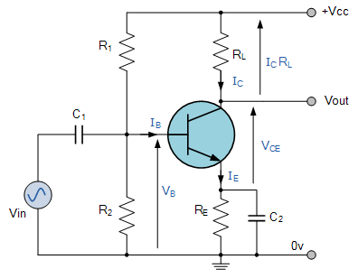
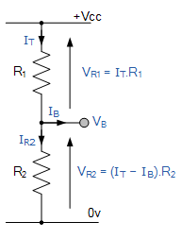
This method of biasing the transistor greatly reduces the effects of varying Beta, ( β ) by holding the Base bias at a constant steady voltage level allowing for best stability. The quiescent Base voltage (Vb) is determined by the potential divider network formed by the two resistors, R1, R2 and the power supply voltage Vcc as shown with the current flowing through both resistors.
Then the total resistance R_{T} will be equal to R1 + R2 giving the current as i = Vcc/R_{T}. The voltage level generated at the junction of resistors R1 and R2 holds the Base voltage (Vb) constant at a value below the supply voltage.
Then the potential divider network used in the common emitter amplifier circuit divides the supply voltage in proportion to the resistance. This bias reference voltage can be easily calculated using the simple voltage divider formula below:

Transistor Bias Voltage
The same supply voltage, (Vcc) also determines the maximum Collector current, Ic when the transistor is switched fully “ON” (saturation), Vce = 0. The Base current Ib for the transistor is found from the Collector current, Icand the DC current gain Beta, β of the transistor.
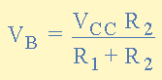

Beta Value
Beta is sometimes referred to as h_{FE} which is the transistors forward current gain in the common emitter configuration. Beta has no units as it is a fixed ratio of the two currents, Ic and Ib so a small change in the Base current will cause a large change in the Collector current.
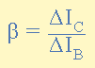
One final point about Beta. Transistors of the same type and part number will have large variations in their Beta value for example, the BC107 NPN Bipolar transistor has a DC current gain Beta value of between 110 and 450 (data sheet value) this is because Beta is a characteristic of the transistors construction and not of its operation.
As the Base/Emitter junction is forward-biased, the Emitter voltage, Ve will be one junction voltage drop different to the Base voltage. If the voltage across the Emitter resistor is known then the Emitter current, Ie can be easily calculated using Ohm’s Law. The Collector current, Ic can be approximated, since it is almost the same value as the Emitter current

PROCEDURE:
- To simulate a transistor in LTSpice, begin by opening the component library, searching for “BC547” and clicking ok.
- Connect the rest of the circuit according to given diagram. Use 1mV AC sine wave source as Vin.
- Power the with a +15V DC source as Vcc.
- Click “Run”, enter proper simulation conditions for a transient analysis and then click “OK”
- Measure the output voltage at “Vo” by connecting probe at the node.
- With same source re-simulate the circuit with proper simulation conditions for an ac analysis and then click “OK”.
- Measure the output voltage at “Vo” by connecting probe at the node.

CONCLUSION:

SAMPLE QUESTIONS:
- Calculate the gain of the amplifier.
- By changing proper parameters increase the gain of the amplifier and simulate the circuit.
- The ac analysis of the amplifier resembles to which filter response?

