EXPERIMENT NO.: 1
AIM: To design and simulate inverting amplifier circuit with op-amp OP-37 using LTSpice.
SOFTWARE USED: LTSpice version IV
THEORY:
An inverting-amplifier circuit is built by grounding the positive input of the operational amplifier and connecting resistors R1 and R2, called the feedback networks, between the inverting input and the signal source and amplifier output node, respectively. With assumption that reverse-transfer parameter is negligibly small, open-circuit voltage gain Av, input resistance Zin and output resistance Zo can be calculated.
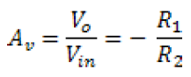
The voltage gain is negative, indicative of an inverting amplifier with a 180 phase shift between dc or sinusoidal input and output signals. In addition, the gain can be greater than or equal to 1 if R₂>R₁, but it can also be less than 1 for R₁ < R₂
The output of this amplifier will invert the waveform like positive magnitude wave will show amplified negative magnitude and vice versa, for example sine wave as input will look like a amplified cosine wave. The positive pulse will generate negative pulse and so on. The ideal operational amplifier adjusts its output to whatever voltage is necessary to force the differential input voltage to zero. However, although the inverting input represents a virtual ground, it is not connected directly to ground.
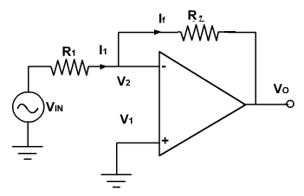
PROCEDURE:
- To simulate an op amp in LTSpice, begin by opening the component library, searching for “OP-37” and clicking ok.
- Connect the positive, negative, and output terminals of the op amp to the rest of the circuit. Use 1V DC source as Vin.
- Power the positive rail of the op amp with a +15V DC source. Connect the negative rail of the op amp to -15V DC source.
- Click “Run”, enter proper simulation conditions for a dc analysis and then click “OK”
- Measure the output voltage at “Vo”
- Now use 1V AC sine wave source as Vin. Re-simulate the circuit with proper simulation conditions for a transient analysis and then click “OK”
- As before measure the input voltage at “Vin” and the output voltage at “Vo.”
- With same source re-simulate the circuit with proper simulation conditions for an ac analysis and then click “OK”.
- Measure the output voltage at “Vo”

CONCLUSION:

SAMPLE QUESTIONS:
- Calculate the gain of the amplifier.
- By changing proper parameters increase the gain of the amplifier and simulate the circuit.
- The ac analysis of the amplifier resembles to which filter response?

