EXPERIMENT NO: 7

AIM: (a) Design and implement D flip-flop using J-K flip-flop.

(b) Design & Implement 3 - bit SISO and SIPO shift register using D flip-flops.

REQUIREMENTS:

SR NO. | COMPONENT | SPECIFICATION | QTY
1 | JK-FF | IC 74109 | 2
2 | INVERTER | IC7404
3 | LEDs | - | 3
4 | CONNECTING WIRES | - | As per req.
5 | IC TRAINER KIT | - | 1
6 | PATCH CORD | - | 3

CIRCUIT DIAGRAM:

Conversion of J-K flip-flop to D flip-flop
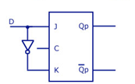

SISO and SIPO Shift Register
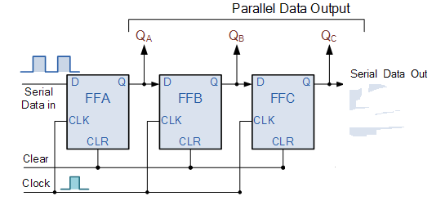

FUNCTION TABLE of IC 74109:

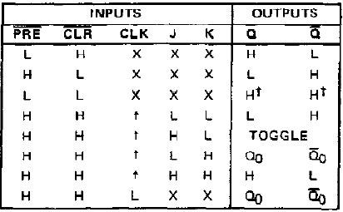

TRUTH TABLE for JK to D Conversion:

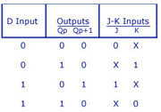

PIN DIAGRAM of IC 74109:

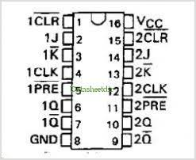
THEORY:
- Conversion of JK flip flop to D flip flop:

In case of converting JK flip flop into D flip flop, D is the external input of combinational circuit, whereas J and K are the inputs of actual flip flop. D and Q_{n} make four combinations. So, prepare a conversion table and using this table express J and K in terms of D and Q_{n}. The conversion table, K-map and logic diagram for the conversion of JK flip flop to D flip flop is shown.

(b) Shift Register:
A shift register basically consists of several single bit “D-Type Data Latches”, one for each data bit, either a logic “0” or a “1”, connected together in a serial type daisy-chain arrangement so that the output from one data latch becomes the input of the next latch and so on.
Data bits may be fed in or out of a shift register serially, that is one after the other from either the left or the right direction, or all together at the same time in a parallel configuration.
The number of individual data latches required to make up a single Shift Register device is usually determined by the number of bits to be stored with the most common being 8-bits (one byte) wide constructed from eight individual data latches.
Shift Registers are used for data storage or for the movement of data and are therefore commonly used inside calculators or computers to store data such as two binary numbers before they are added together, or to convert the data from either a serial to parallel or parallel to serial format. The individual data latches that make up a single shift register are all driven by a common clock ( Clk ) signal making them synchronous devices.
Shift register IC’s are generally provided with a clear or reset connection so that they can be “SET” or “RESET” as required. Generally, shift registers operate in one of four different modes with the basic movement of data through a shift register being:
- Serial-in to Parallel-out (SIPO) - the register is loaded with serial data, one bit at a time, with the stored data being available at the output in parallel form.
- Serial-in to Serial-out (SISO) - the data is shifted serially “IN” and “OUT” of the register, one bit at a time in either a left or right direction under clock control.
- Parallel-in to Serial-out (PISO) - the parallel data is loaded into the register simultaneously and is shifted out of the register serially one bit at a time under clock control.
- Parallel-in to Parallel-out (PIPO) - the parallel data is loaded simultaneously into the register, and transferred together to their respective outputs by the same clock pulse.

DESIGN STEPS:

(a) Conversion of JK flip flop to D flip flop:
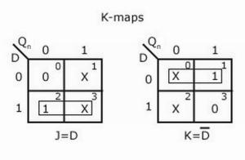
Since the IC used here is 74109 with active low K input the above design changes to

J = D and K = D

- Shift Register

For designing 3-bit shift register three D flip-flops are connected one after another as shown in fig. Same clock is given to all the flip-flops. For SISO, output is taken from the last flip-flop and for SIPO, outputs of all the flip-flops are taken at a time.

Output waveform :
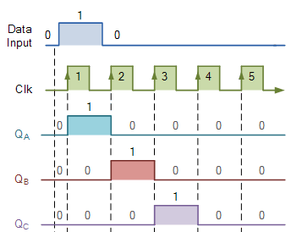

PROCEDURE:

- Ring up the circuit as per the circuit diagram on IC trainer kit.
- Give logical inputs as per the respective function given.
- Observe the logical output and verify with your truth table.

CONCLUSION:

