EXPERIMENT NO: 6

AIM: (a) Design and implement T flip-flop using J-K flip-flop.

(b) Design & Implement 2 - bit asynchronous counter using T flip-flops.

REQUIREMENTS:

SR NO. | COMPONENT | SPECIFICATION | QTY
1 | JK-FF | IC 74109 | 2
2 | INVERTER | IC7404
3 | LEDs | - | 3
4 | CONNECTING WIRES | - | As per req.
5 | IC TRAINER KIT | - | 1
6 | PATCH CORD | - | 3

CIRCUIT DIAGRAM:

Conversion of J-K flip-flop to T flip-flop
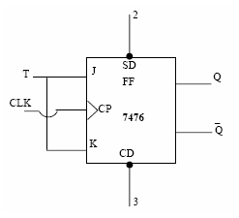

3-bit asynchronous up counter

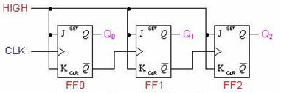

FUNCTION TABLE of IC 74109:

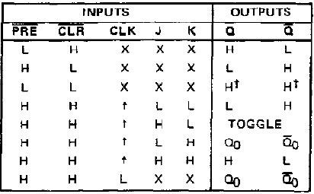
TRUTH TABLE for JK to T Conversion:
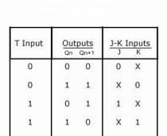

PIN DIAGRAM of IC 74109:

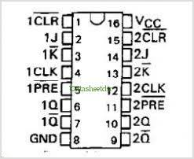
THEORY:
(a) Conversion of JK flip flop to T flip flop:

For the conversion of JK flip flop to T type of flip flop, T will be the external input (input of combinational circuit) and the output of this combinational circuit is connected to the inputs of actual flip flop (J and K).
Then we prepare conversion table and using this table express J and K in terms of T and Q_{n}.

(b) Counter:
A counter is a sequential logic circuit that goes through a prescribed sequence of states upon the application of input pulses.
Asynchronous Counter:
Counters arranged so that the output of one flip-flop generates the clock input of the next higher stage are generally called asynchronous counters (or ripple counter). In other words, in asynchronous counters, the CLK inputs of all flip-flops (except the first one) are triggered not by the incoming pulses but rather by the transition that occurs in other flip-flops. Therefore, the change of state of a particular flip-flop is dependent upon the present state of other flip-flops. Since each flip-flop has a non-zero propagation delay, ripple counters are relatively slow. Therefore, an upper limit on the number of flip-flops in the flip-flop chain ought to be imposed.

DESIGN STEPS:

(a) Conversion of JK flip flop to T flip flop:
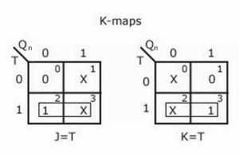

Since the IC used here is 74109 with active low K input, one inverter is required to be connected before K input for the above design. So,

J = T but K = T’ for this IC.

(b) 2-bit asynchronous up counter

An “up” counter may be made by connecting the clock inputs of positive-edge triggered J-K flip-flops to the Q’ outputs of the preceding flip-flops. The J input of all flip-flops are connected to V_{cc} or V_{dd} so as to always be “high” and K input are connected to Ground as this input is active low for IC 74109.
Output waveform:
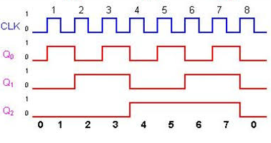

(c) 2-bit asynchronous down counter
A “down” counter may be made by connecting the clock inputs of positive-edge triggered J-K flip-flops to the Q outputs of the preceding flip-flops. The J input of all flip-flops are connected to V_{cc} or V_{dd} so as to always be “high” and K input are connected to Ground as this input is active low for IC 74109.

PROCEDURE:

- Ring up the circuit as per the circuit diagram on IC trainer kit.
- Give logical inputs as per the respective function given.
- Observe the logical output and verify with your truth table.

CONCLUSION:

