EXPERIMENT NO.: 5

AIM: Design & Implement full subtractor using IC74138.

REQUIREMENTS:

SR NO. | COMPONENT | SPECIFICATION | QTY
1 | OR GATE | IC 7432 | 1
2 | 3:8 DECODER | IC 74138 | 1
3 | NAND GATE | IC 7400 | 2
4 | LEDs | - | 2
5 | CONNECTING WIRES | - | As per req.
6 | IC TRAINER KIT | - | 1
7 | PATCH CORD | - | 05

CIRCUIT DIAGRAM:

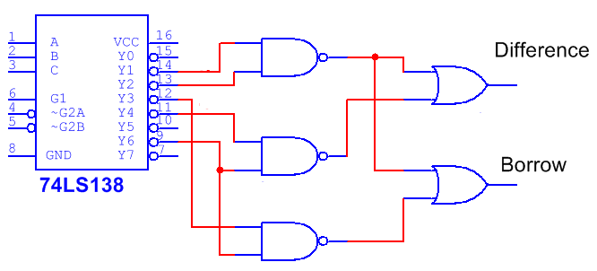

FUNCTIONAL TRUTH TABLE of IC 74138:

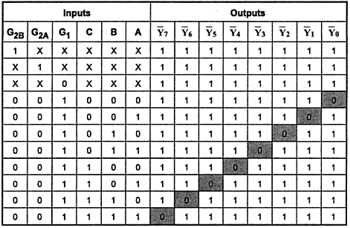
TRUTH TABLE of FULL SUBTRACTOR :

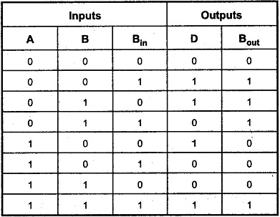

PIN DIAGRAM of IC 74138 :

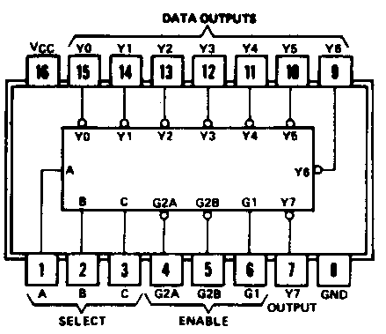

THEORY:
A decoder is a multiple input multiple output logic circuit which converts coded input into coded output where input and output codes are different. The input code generally has fewer bits than the output code. Each input code word produces a different output code word i.e there is one to one mapping can be expressed in truth table.
The IC74138 is the 3 x 8 decoder which contains three inputs and 8 active low outputs and also three enables out of them two are active low and one is active high. Decoders are used in the circuit where required to get more outputs than that of the inputs.

Applications of Decoder:
- Used in electronic circuits to convert instructions into CPU control signals.
- They mainly used in logical circuits, data transfer.

DESIGN STEPS:

Expression for Difference (D):
D(A,B,B_{IN}) = ∑m(1,2,4,7)

Expression for Borrow (B_{OUT}):
B_{OUT} (A,B, B_{IN}) = ∑m(1,2,3,7)

PROCEDURE:

- Ring up the circuit as per the circuit diagram on IC trainer kit.
- Give logical inputs as per the respective function given.
- Observe the logical output and verify with your truth table.

CONCLUSION:

SAMPLE QUESTIONS:
- Design a full subtractor using 3:8 decoder.

- Distinguish DEMUX and decoder.
- Compare Encoder & Decoder.

