EXPERIMENT NO.: 4

AIM : Design and implement the given function using IC 74153.

REQUIREMENTS:

SR No. | COMPONENT | SPECIFICATION | QTY
1. | 4: 1 Multiplexer | IC 74153 | 3
2. | IC TRAINER KIT | - | 1
3. | PATCH CORD | - | 14

CIRCUIT DIAGRAM :
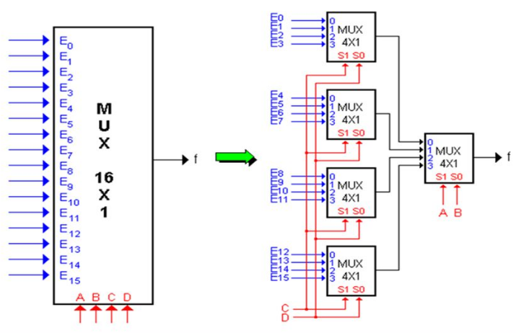

FUNCTIONAL TRUTH TABLE of IC 74153:

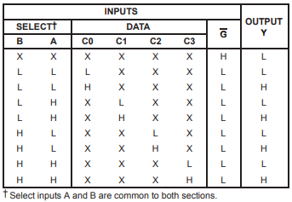
TRUTH TABLE for 16:1 MUX:
Select Inputs |  |  |  | Output
A | B | C | D | Y
0 | 0 | 0 | 0 | E₀
0 | 0 | 0 | 1 | E₁
0 | 0 | 1 | 0 | E₂
0 | 0 | 1 | 1 | E₃
0 | 1 | 0 | 0 | E₄
0 | 1 | 0 | 1 | E₅
0 | 1 | 1 | 0 | E₆
0 | 1 | 1 | 1 | E₇
1 | 0 | 0 | 0 | E₈
1 | 0 | 0 | 1 | E₉
1 | 0 | 1 | 0 | E₁₀
1 | 0 | 1 | 1 | E₁₁
1 | 1 | 0 | 0 | E₁₂
1 | 1 | 0 | 1 | E₁₃
1 | 1 | 1 | 0 | E₁₄
1 | 1 | 1 | 1 | E₁₅

PIN DIAGRAM of IC 74153:

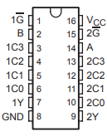

THEORY:

Multiplexer, also known as data selector, is a combinational logic circuit designed to switch one of several input lines through to a single common output line by the application of a control signal.
Multiplexers are capable of handling both analog and digital applications. In analog applications, multiplexers are made up of of relays and transistor switches, whereas in digital applications, the multiplexers are built from standard logic gates. When the multiplexer is used for digital applications, it is called a digital multiplexer.

Applications of Multiplexers:
Multiplexers are used in various applications wherein multiple-data need to be transmitted by using single line.
- Communication System
A communication system has both a communication network and a transmission system. By using a multiplexer, the efficiency of the communication system can be increased by allowing the transmission of data, such as audio and video data from different channels through single lines or cables.
- Computer Memory
Multiplexers are used in computer memory to maintain a huge amount of memory in the computers, and also to reduce the number of copper lines required to connect the memory to other parts of the computer.
- Telephone Network
In telephone networks, multiple audio signals are integrated on a single line of transmission with the help of a multiplexer.
- Transmission from the Computer System of a Satellite
Multiplexer is used to transmit the data signals from the computer system of a spacecraft or a satellite to the ground system by using a GSM satellite.

PROCEDURE:

- Ring up the circuit as per the circuit diagram on IC trainer kit.
- Give logical inputs as per the respective function given.
- Observe the logical output and verify with your truth table.

CONCLUSION:

