EXPERIMENT NO.: 2

AIM : Design and implement 4-bit adder and subtractor using IC 7483.

REQUIREMENTS:

SR No. | COMPONENT | SPECIFICATION | QTY
1. | 4-bit binary adder | IC 7483 | 1
2. | X-OR GATE | IC 7486 | 1
3. | IC TRAINER KIT | - | 1
4. | PATCH CORD | - | 14

CIRCUIT DIAGRAM :
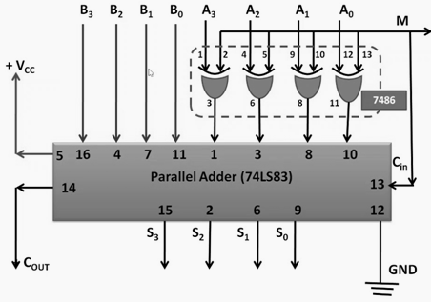

FUNCTIONAL TRUTH TABLE:

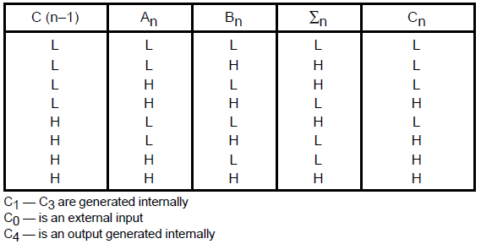
PIN DIAGRAM:

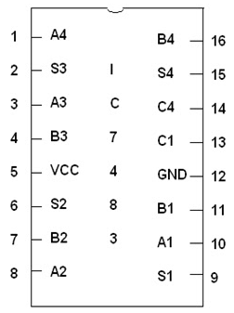

THEORY:

The 74LS83A is a high-speed 4-Bit binary Full Adder with internal carry look-ahead. It performs the addition of two 4-bit binary numbers A₃A₂ A₁A₀ and B₃B₂B₁B₀ and carry input to give the output S₃ S₂ S₁S₀ and carry out.

So for adding the two numbers A₃A₂ A₁A₀ and B₃B₂B₁B₀ , the two numbers are given to input terminals 1,3,8,10 and 16,4,7,11 of the IC 7483 and carry in the terminal 13 is set to zero.

To subtract two numbers by two’s compliment method, the 2’s compliment of the second number is added to each of the four bits of the first numbers. If the final carry is ‘1’ then it is neglected and the difference is taken from S₃ S₂ S₁S₀ which will be positive. If the final carry is ‘0’ then the difference is taken from S₃ S₂ S₁S₀ which will be negative and in 2’s complement form.

In the circuit the mode control is set such that when the mode control is ‘0’, addition is performed and subtraction is performed when the mode control is ‘1’. XOR gates are used to feed the input so that when mode control is one, the 1’s complement of each of the four bits are fed with carry in ‘1’ and when mode control is zero, the input as such is fed.

PROCEDURE:

- Ring up the circuit as per the circuit diagram on IC trainer kit.
- Give logical inputs as per the respective truth table.
- Observe the logical output and verify with your truth table.
CONCLUSION:

