EXPERIMENT NO.: 2

AIM : Design and implement half adder and full adder circuits and verify the truth tables.

REQUIREMENTS:

SR No. | COMPONENT | SPECIFICATION | QTY
1. | AND GATE | IC 7408 | 1
2. | OR GATE | IC 7432 | 1
3. | NOT GATE | IC 7404 | 1
4. | X-OR GATE | IC 7486 | 1
5. | IC TRAINER KIT | - | 1
6. | PATCH CORD | - | 14

CIRCUIT DIAGRAM and TRUTH TABLE:

- Half Adder:
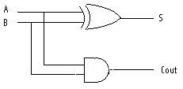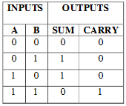

- Full Adder:

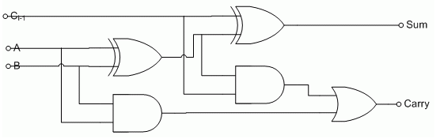

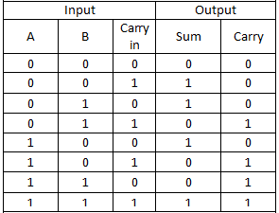
THEORY:

HALF ADDER
A half adder adds two one-bit binary numbers A and B. It has two outputs, S and C (the value theoretically carried on to the next addition). The simplest half-adder design incorporates an XOR gate for S and an AND gate for C. Half adders cannot be used compositely, given their incapacity for a carry-in bit.
S = A $⊕$ B

C = A.B
FULL ADDER
A full adder adds binary numbers and accounts for values carried in as well as out. A one-bit full adder adds three one-bit numbers, often written as A, B, and Cin; A and B are the operands, and Cin is a bit carried in (in theory from a past addition). The circuit produces a two-bit output sum typically represented by the signals Cout and S.
S = A $⊕$B $⊕$Cin

Cout = A.B + A.Cin + B.Cin = (A $⊕$ B).Cin + A.Cin
PROCEDURE:

- Ring up the circuit as per the circuit diagram on IC trainer kit.
- Give logical inputs as per the respective truth table.
- Observe the logical output and verify with your truth table.
CONCLUSION:

