EXPERIMENT NO.: 6

AIM: Design & Implement full adder using 3: 8 decoder IC74138.

REQUIREMENTS:

SR NO. | COMPONENT | SPECIFICATION | QTY
1 | OR GATE | IC 7432 | 2
2 | DECODER | IC 74138 | 2
3 | NOT GATE | IC 7404 | 1
4 | LEDs | - | 2
5 | CONNECTING WIRES | - | As per req.
6 | IC TRAINER KIT | - | 1
7 | PATCH CORD | - | 08

PIN DIAGRAM:
3:8 DECODER IC 74138

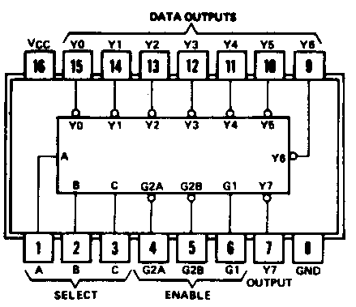
TRUTH TABLE:
3:8 DECODER IC 74138

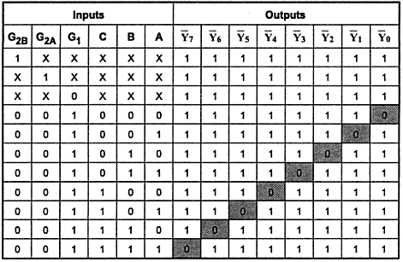
FULL ADDER:
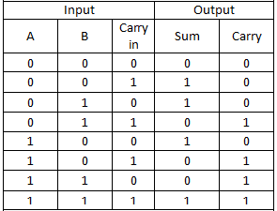

CIRCUIT DIAGRAM:
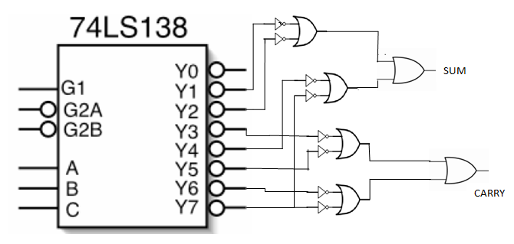

THEORY:
DECODER
A decoder is a multiple input multiple output logic circuit which converts coded input into coded output where input and output codes are different. The input code generally has fewer bits than the output code. Each input code word produces a different output code word i.e there is one to one mapping can be expressed in truth table.
The IC74138 is the 3 x 8 decoder which contains three inputs and 8 outputs and also three enables out of them two are active low and one is active high. Decoders are used in the circuit where required to get more outputs than that of the inputs.

DESIGN STEPS:

To design full adder using decoder IC 74138 first the outputs of the decoder IC are inverted using NOT gate as the outputs are active low. Then using separate OR gates the respective minterms for SUM expression and and CARRY (COUT) expression can be combined to give the correct output.
Expression for Sum (S):
S(A,B,CIN) = ∑m(1,2,4,7)

Expression for Carry (COUT):
COUT(A,B,CIN) = ∑m(3,5,6,7)

PROCEDURE:

- Connect VCC and ground pins of IC to the power supply.
- Connect the circuit on bread board as per the design.
- Connect LEDs at output pins and verify the truth table.

CONCLUSION:

SAMPLE QUESTIONS:
- Design a full subtractor using 3:8 decoder.

- Distinguish DEMUX and decoder.
- Compare Encoder & Decoder.

