Question Bank Answers– Term Test 2
2Marks:
- Explain Aliasing Effect with neat diagram?
Aliasing Effect is also called as Under Sampling (f_{s} < 2f_{m}) .
Overlapping of high frequency components with low frequency components is known as aliasing.
Because of aliasing the original signal cannot be reconstructed from its samples. Aliasing can be avoided if the highest frequency components of the signal f_{m} is less than or equal to fs /2
fm<= fs/2 where, fs = 1/Ts
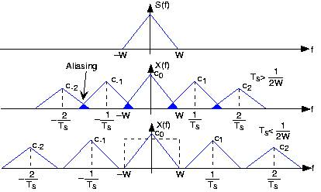
Fig Frequency spectrum of Aliasing Effect and Anti-aliasing effect

- State Sampling Theorem
A band limited signal with highest frequency component fm corresponding can be uniquely determined from the sample if sampling frequency is greater than or equal to twice the maximum frequency of the signal
fs>= 2fm
- A Band pass Signal has a spectral range that extends from 30 KHz to 75 KHz. Find the sampling Frequency?
Given: f1 = 30KHz f2 = 75KHz
Sampling frequency, fs = 2fm
Bandwidth, f2-f1 = 75 kHz – 30 kHz = 45 kHz
Sampling frequency fs = 2B = 2 * 45 kHz = 90 kHz
- Explain the Generation of PAM?
Pulse Amplitude Modulation:
Pulse Amplitude Modulation is a basic form of pulse modulation in which the signal is sampled at regular and each sample is made proportional to the amplitude of the modulating signal.
PAM is a form of signal modulation where the message information encoded in the amplitude of a series of signal pulses.

PAM

Sampler
(Multiplier)
Modulating
Signal

Sampling
Signal

Thus the amplitude of the signal is proportional to the modulating signal through which the information is carried. This is Pulse Amplitude modulation signal.
PAM is used to transmitting analog information such as continuous speech signal or data.
- Draw the Block diagram of Digital Communication System
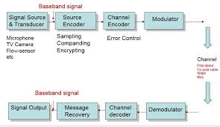
- What is Line coding and Give Examples? (Chapter -5)
A line code is the code used for data transmission of a digital signal over a transmission line. This process of coding is chosen so as to avoid overlap and distortion of signal such as inter-symbol interference.
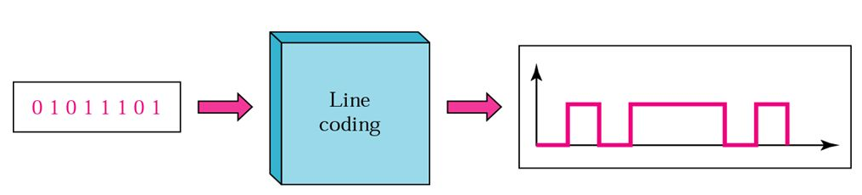
There are 3 types of Line Coding,
- Unipolar: Unipolar signaling is also called as On-Off Keying or simply OOK.
The presence of pulse represents a 1 and the absence of pulse represents a 0.
There are two variations in unipolar signaling −
Non Return to Zero (NRZ) Return to Zero (RZ)
- Polar: There are two methods of Polar Signaling. They are −
- Polar NRZ
- Polar RZ
- Bi-polar: This is an encoding technique which has three voltage levels namely +, - and 0. Such a signal is called as duo-binary signal.
An example of this type is Alternate Mark Inversion (AMI). For a 1, the voltage level gets a transition from + to – or from – to +, having alternate 1s to be of equal polarity. A 0 will have a zero voltage level.
- Compare TDM and FDM?
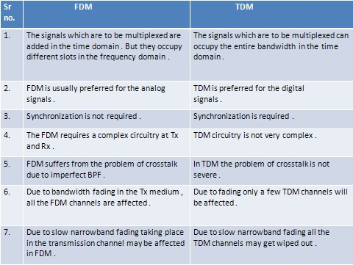
- What is Bit rate and Baud rate?
Bit rate and Baud rate, these two terms are often used in data communication.
Bit rate: Bit rate is simply the number of bits (i.e., 0’s and 1’s) transmitted in per unit time.
Baud rate: Baud rate is the number of signal units transmitted per unit time that is needed to represent those bits.
The crucial difference between bit rate and baud rate that one change of state can transfer one bit, or slightly more or less than one bit that relies on the modulation technique used.
Hence, the given equation defines the relation between the two:
Bit rate = baud rate x the number of bit per baud

- What is Probability of Error and Bandwidth Requirement of BPSK?
Error probability:
- We know that BPSK signal is represented as follows:
Binary 1:x1(t)=$√$2Ps cosωCt
Binary 0: x2(t)=−$√$2Ps cosωCt
Therefore x2(t)=−x1(t)
- By using the matched filter for detection of BPSK signal. The expression for error probability of an optimum filter is,
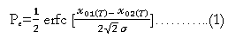
- The expression for the signal to noise ration of matched filter is given by,
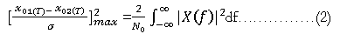
- Using the Rayleigh’s energy theorem,
- The limits of integration of the last term in equation (3) are 0 to T because x (t) is present only over one bit interval T. Substituting equation (3) into equation (2) we get,
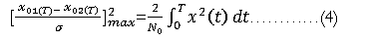
- But x (t)=x1(t)−x2(t) and for BPSK x2(t)=−x1(t)
- Substituting this value of x (t) into equation (4) we get,
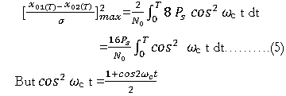
- Substitute this into equation (5) to get
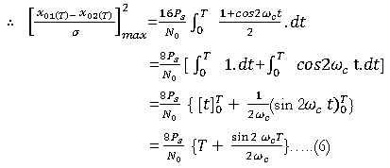
- The value of second term in the RHS in equation (6) is zero
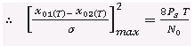
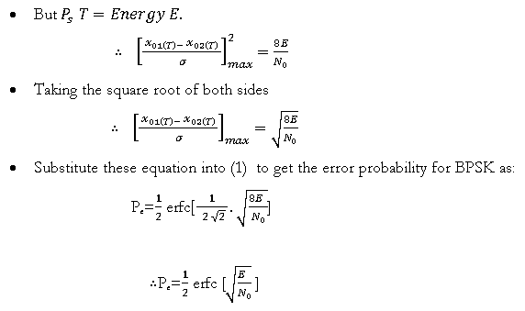
Bandwidth of BPSK:
- From the frequency spectrum of BPSK signal ,it is clear that the bandwidth of a BPSK signal is given by,
BW= Highest frequency – Lowest frequency in main lobe =(fc+fb)−(fc−fb)
∴ BW=2 fb, Where fb=1/Tb
- Thus the minimum bandwidth of BPSK signal is equal to twice the highest frequency contained in the baseband signal.

- What are the Drawback of Delta Modulation?
Delta modulation has two major drawbacks that are:
- Slope overload distortion
This distortion arises because of large dynamic range of input signal. To reduce this error, the step size must be increased when slope of signal x(t) is high. Since the step size of delta modulator remains fixed, its maximum or minimum slopes occur along straight lines. Therefore, this modulator is known as Linear Delta Modulator (LDM).
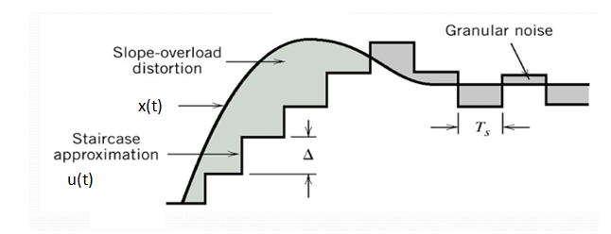
- Granular noise
Granular noise occurs when step size is too large compared to small variations in the input signal. This means that for very small variations in the input signal, the staircase signal is changed by large amount because of large step size. The error between the input and approximated signal is called granular noise. The solution to this problem is to make step size small. Adaptive Delta Modulation
To overcome the quantization error due to slope overload distortion and granular noise, the step size (Δ) is made adaptive to variations in input signal x(t). Particularly in the step segment of the x(t) , the step size is increased. Also, if the input is varying slowly, the step size is reduced. Then this method is known as Adaptive Delta Modulation (ADM). The adaptive delta modulators can take continuous changes in the step size or discrete changes in the step size
- What is Multiplexing in Communication System?
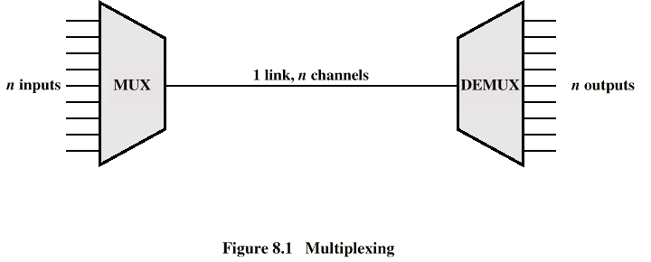
Whenever the bandwidth of a medium linking two devices is greater than the bandwidth needs of the devices, the link can be shared.
- Multiplexing is the set of techniques that allows the (simultaneous) transmission of multiple signals across a single data link.
- De- multiplexing takes the data stream from one high-speed line and breaks it into portions that can be sent across several lower-speed lines simultaneously, with no loss in the collective data rate.
- Compare PCM and Delta Modulation and Adaptive delta Modulation?
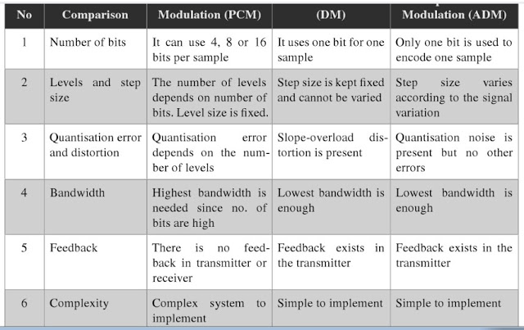
- Explain Slope Overload Error and Hunting Error in Delta Modulation?
Slope overload distortion
This distortion arises because of large dynamic range of input signal. To reduce this error, the step size must be increased when slope of signal x(t) is high. Since the step size of delta modulator remains fixed, its maximum or minimum slopes occur along straight lines. Therefore, this modulator is known as Linear Delta Modulator (LDM).
Granular noise: Granular noise occurs when step size is too large compared to small variations in the input signal. This means that for very small variations in the input signal, the staircase signal is changed by large amount because of large step size. The error between the input and approximated signal is called granular noise. The solution to this problem is to make step size small. Adaptive Delta Modulation
To overcome the quantization error due to slope overload distortion and granular noise, the step size (Δ) is made adaptive to variations in input signal x(t). Particularly in the step segment of the x(t) , the step size is increased. Also, if the input is varying slowly, the step size is reduced. Then this method is known as Adaptive Delta Modulation (ADM). The adaptive delta modulators can take continuous changes in the step size or discrete changes in the step size
- What is LINE CODING? Draw the Bipolar NRZ and MANCHESTER Signal for the following Binary signal 10111010.
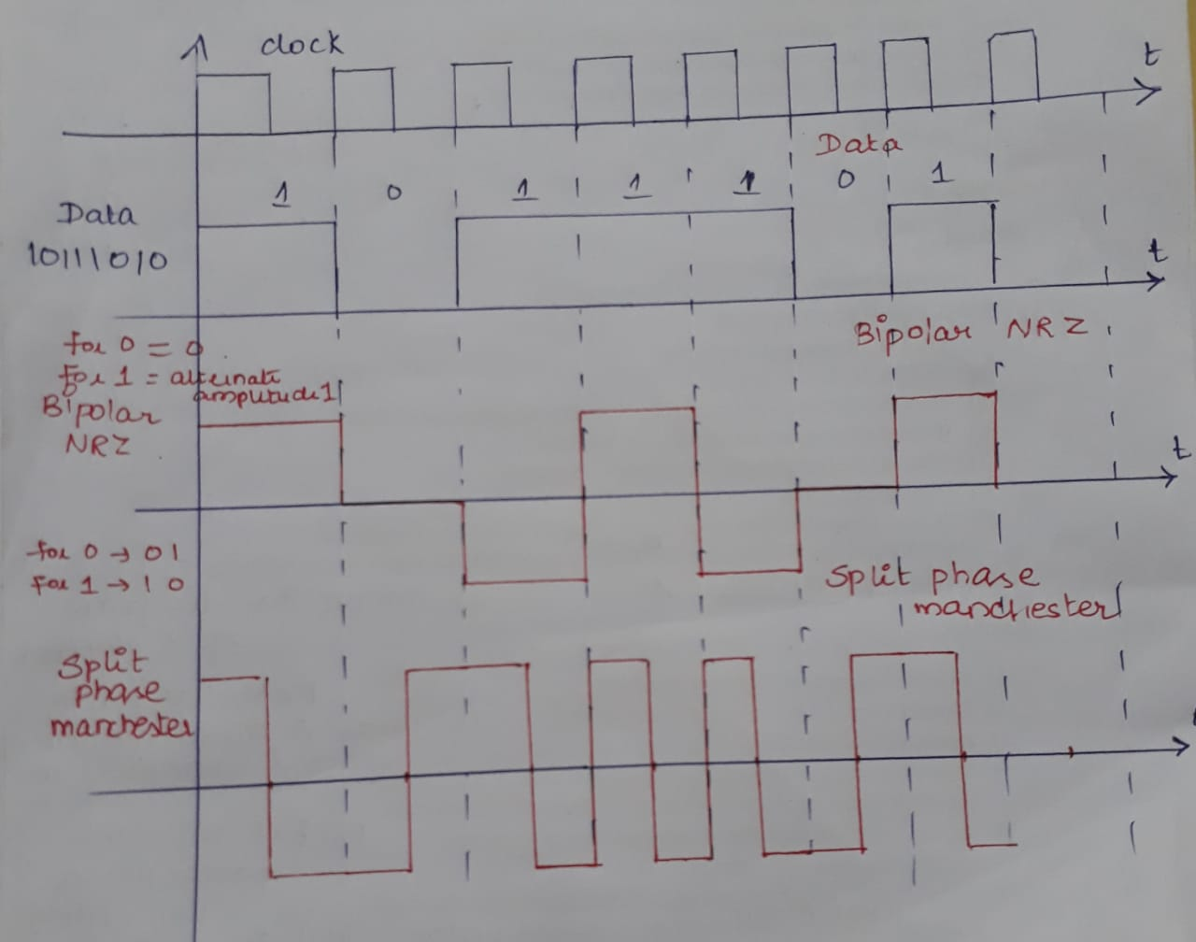
- Draw the diagram of 4 Channel PAM- TDM system?
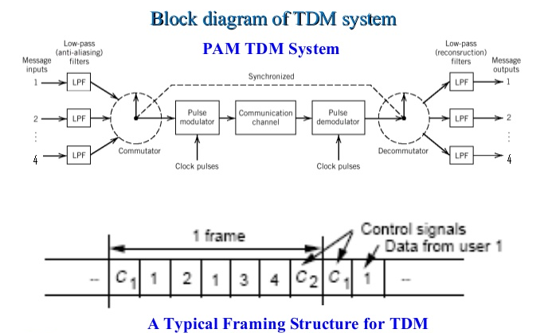
- What is Quantization Error and Quantization Noise?

Quantization Error
The difference between an input value and its quantized value is called a Quantization Error. A Quantizer is a logarithmic function that performs Quantization (rounding off the value). An analog-to-digital converter (ADC) works as a quantizer.

Quantization Noise
It is a type of quantization error, which usually occurs in analog audio signal, while quantizing it to digital. For example, in music, the signals keep changing continuously, where a regularity is not found in errors. Such errors create a wideband noise called as Quantization Noise.
- Explain the Properties of Line coding?
- As the coding is done to make more bits transmit on a single signal, the bandwidth used is much reduced.
- For a given bandwidth, the power is efficiently used.
- The probability of error is much reduced.
- Error detection is done and the bipolar too has a correction capability.
- Power density is much favorable.
- The timing content is adequate.
- Long strings of 1s and 0s is avoided to maintain transparency.
- Show the encoding and decoding of the binary data 0010011 of DEPSK with reference bit 0
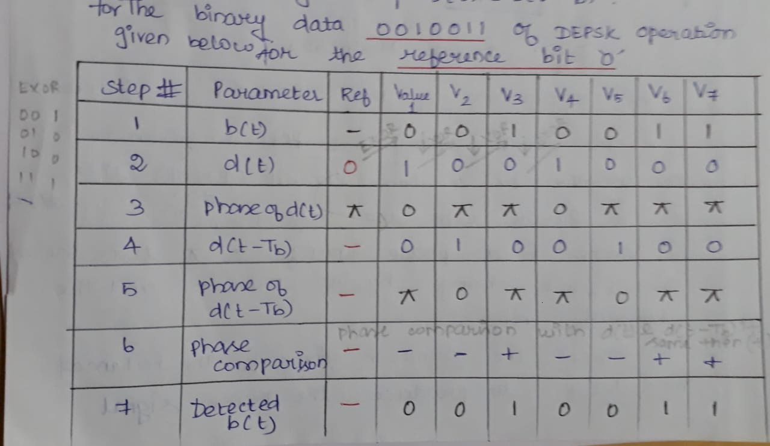

- Draw the Constellation diagram of 16 QAM and M-ary PSK
Constellation diagram for 16QAM
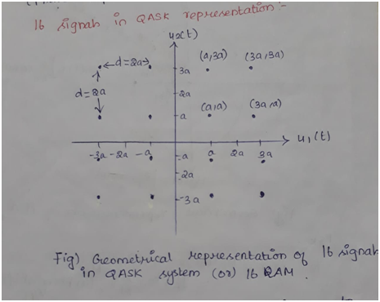
Constellation diagram for M-ary PSK
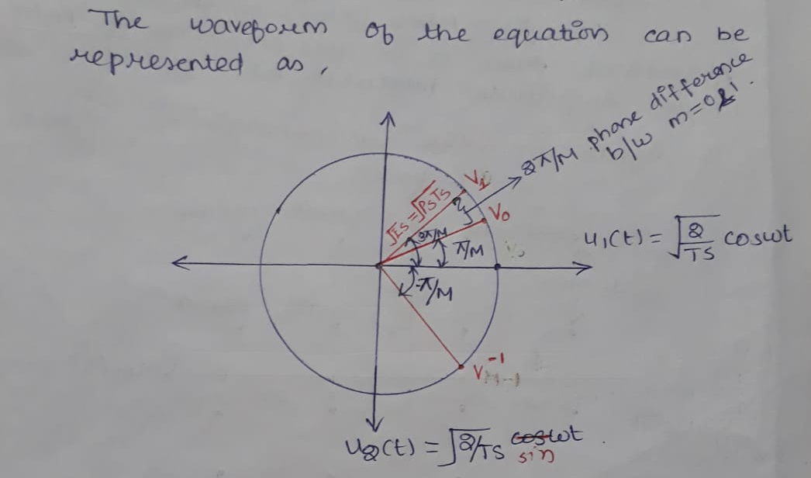
- What are the Types of Propagation and explain each? (Refer Module 6 Notes Types of propogation) (Chapter -6)

