Question Bank Answers for Term Test -1
2Marks
- Explain Frequency and Wavelength
Frequency:
"Frequency id defined as the number of waves that pass a point in space each second." In electronics frequency is the number of cycles of a repetitive wave that occurs in a given time period. The unit of frequency is hertz, named for the German physicist Heinrich Hertz.
Wavelength:
“It is defined as the distance travelled by an wave during the time of ine cycle occupied in free space”.
Wavelength decreases with increase in frequency.
Wavelength = Speed of light
Frequency
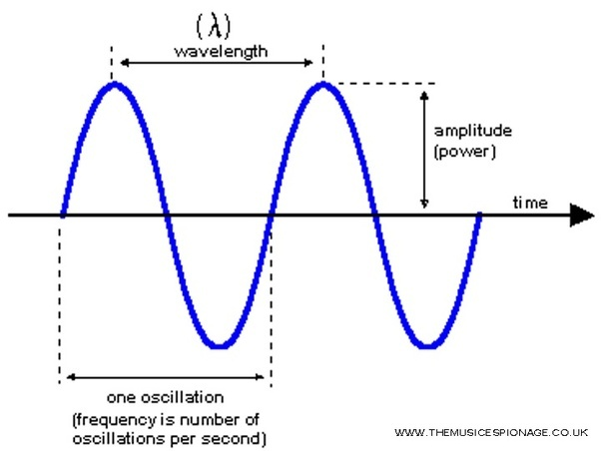
- Define Modulation and explain any two need for modulation
Modulation
Modulation is an important step of communication system. Modulation is defined as the process whereby some characteristic (like amplitude, frequency, phase of a high frequency signal wave (carrier wave) is varied in accordance with instantaneous value intensity of low frequency signal wave (modulating wave.)

Need for modulation : –
i) To separate signal from different transmitters :-
Audio frequencies are within the range of 20 Hz to 20 kHz. Without modulation all signals at same frequencies from different transmitters would be mixed up. There by giving impossible situation to tune to any one of them. In order to separate the various signals, radio stations must broadcast at different frequencies.
Each radio station must be given its own frequency band. This is achieved by frequency translation as a result of modulation process.
ii) Size of the antenna : –
For efficient transmission the transmitting antennas should have length at least equal to a quarter of the wavelength of the signal to be transmitted. For an electromagnetic wave of frequency 15 kHz, the wavelength λ is 20 km and one-quarter of this will be equal to 5 km. Obviously, a vertical antenna of this size is impractible. On the other hand, for a frequency of 1 MHz, this height is reduced to 75 m.
Also, the power radiated by an antenna of length l is proportional to (l/λ). This shows that for the same antenna length, power radiated is large for shorter wavelength. Thus, our signal which is of low frequency must be translated to the high frequency spectrum of the electromagnetic wave. This is achieved by the process of modulation.
- State and Prove Shifting property of Fourier Transform
If x(t)⟷F.T X(f) then Time shifting property states that x(t−t0)⟷F.T e^{−j i2πft0} X(f)
Proof:
(proof ) By definition, F{x(t − t0)} = $\int_{-∞}^{∞}{x(t - t0)}$ e ^{−i2πf t}dt
let u = t − t0,
then F{x(t−t0)} = $\int_{-∞}^{∞}{x(u)}$e ^{−i2πf(u+t0)} du
= $\int_{-∞}^{∞}{x(u)}$e ^{−i2πf(u)} du·e ^{−i2πf t0}
= X(f)e ^{−i2πf t0}
Hence Proved

- How the selectivity and sensitivity will be improved in superhetrodyne reciever as compare to TRF reciever
Use of the fixed lower Intermediate Frequency channel gives the following improvement:
- for a given Q factor in the tuned circuits, the bandwidth is lower making it easier to achieve the required selectivity.
- At lower frequencies, circuit losses are often lower allowing higher Q factors to be achieved and hence, even greater selectivity and higher gain in the tuned circuits.
- It is easier to control, or shape, the bandwidth characteristic at one fixed frequency. Filters can be easily designed with a desired Band-pass characteristic and slope characteristic, an impossible task for circuits which tune over a range of frequencies.
- Since the receiver selectivity and most of the receiver pre-detection gain, are both controlled by the fixed IF stages, the selectivity and sensitivity and gain of the super-heterodyne receiver are more consistent over its tuning range than in the TRF receiver.
- Compare analog and Digital Communication system
PARAMETERS | ANALOG COMMUNICATION | DIGITAL COMMUNICATION
Definiton | Analog Communication is the technology which uses Analog signal for the transmission of information. | Digital Communication is the technology which uses digital signal for the transmission of information.
Noise and Distortion | Get affected by Noise | Immune from Noise and Distortion
Error Probability | Error Probability is high due to parallax. | Error Probability is low
Hardware | Hardware is complicated and less flexible than digital system. | Hardware is flexible and less complicated than Analog system.
Cost | Low Cost | High Cost
Bandwidth Requirement | Low bandwidth requirement | High bandwidth Requirement
Power Requirement | High power is required | Low Power Requirement
Portability | Less Portable as the components are heavy | More portable due to compact equipments.
Modulation Used | Amplitude and Angle Modulation | Pulse coded Modulation or PCM, DPCM etc.
Representation of Signal | Analog signal can be represented by sine wave. | Digital signal is represented by square wave.
Signal Values | Consists of continuous values | Consists of discrete values
Example of Signal | Analog signal comprises of voice, sound etc. | Digital signals are used in computers

- State and Prove Differentiation in time domain property of the Fourier Transform
This property is applicable if and only if the derivative of x(t) is fourier transformable.
Statement:
Let x(t) < -------------> X(f) and let the derivative of x(t) be fourier transformable then,
x(t) = $\frac{dx(t)}{dt}$< -------------> X(f) = j2πf X(f)
Proof:
x(t) = $\int_{-∞}^{∞}{X\left(f) {(e}^{j2πft}\right)}$ df
differentiate on both sides,
$\frac{dx(t)}{dt}$ = $\frac{d}{dt}$[$\int_{-∞}^{∞}{X\left(f)( {\begin{aligned} \\ e\end{aligned}}^{j2πft}\right)}$ df ]

= $\int_{-∞}^{∞}{ \frac{d}{dt} X\left( f{)(e}^{j2πft}\right)}$ df

= $\int_{-∞}^{∞}{ X\left(f{)( e}^{j2πft}\right)} j2πf df$

= j2πf $\int_{-∞}^{∞}{ X\left(f{)( e}^{j2πft}\right)}$ df

= j2πf x(t)
FT[$\frac{dx(t)}{dt}$] = j2πf FT [ x(t) ]
= j2πf X(f)

Hence Proved.

- An amplifrier has a Bandwidth of 4 Mhz with 10k as the input resistor. Calculate the RMS noise voltage at the input to this amplifier, if the room temperature is 25ºC
Given: B= 4Mhz R = 10k T= 25ºc = 273+25 = 298K
RMS Noise Voltage = $\sqrt{4KTBR}$
= $\sqrt{4*1.38*10-23*298*4MHZ*10K}$
= 0.00002565119 = 25.65 *10⁻⁶v

- Explain Noise Figure and Noise Factor
Noise Figure:
- Noise Figure is simply the noise factor stated in dB and is a parameter commonly used to indicate the quality of a receiver
- Mathematically Noise Figure is,
NF (dB) = 10log₁₀ (Input signal to noise power ratio)
(output signal to noise power ratio)

= 10 log₁₀ (S/N)_{i} – 10log₁₀(S/N)_{o}

= 10log₁₀ F

- The noise figure will be 1 for an ideal receiver. Practical receiver will generate some noise, and the SNSN will deteriorate as one move toward the output.

Noise Factor:
Noise Factor is to indicate how much the signal to noise ratio deteriorates as a signal passes through a circuit or series of circuits.
Noise Factor is simply a ratio of Input signal to noise power ratio to Output signal to noise power ratio
F = (Input signal to noise power ratio)
(output signal to noise power ratio)

` = (P_{si /} P_{ni) /} (P_{so /} P_{no)}
where, Psi and Pni – signal and noise power at the input
Pso and Pno – signal and the noise power at the output

- Explain Noise Bandwidth and Noise Temperature
- The noise bandwidth “BN” is defined as the bandwidth of an ideal (rectangular) filter which passes the same noise power as does the real filter.
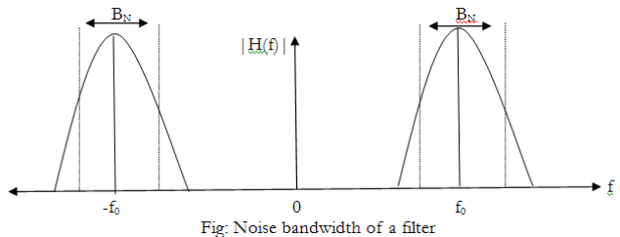
- Assume that a white noise is present at the input of a receiver (filter).
- Let the filter have a transfer function H (f) as shown in fig.
- This filter is being used to reduce the noise power actually passed on to the receiver.
- Now consider the dotted plot (ideal filter)
- The centre frequency of this ideal filter is f0f0
- Let the bandwidth “BN” of the ideal filter be adjusted in such a way that the noise output power of the ideal filter is exactly equal to the noise output power of a real R-C filter.
Then “BN” is called as the noise bandwidth of the real filter.
Equivalent Noise Temperature
- The equivalent noise temperature of a system is defined as the temperature at which the noise resistor has to be maintained so that by connecting this resistor to the input of a noiseless version of the system, it will produce the same amount of noise power at the system output as that produced by the actual system.
- The noise at the input of the amplifier input is given by
Pna=(F−1)kTcB
This is the noise contributed by the amplifier. This noise power can be alternatively represented by some fictitious temperature Teq such that
KTeqB=(F−1)kTcB
Thus the equivalent noise temperature of the amplifier is given by
Teq=(F−1)Tc
This equation shows that Teq is just an alternative measre for F.
- State the advantage of Digital Communication over Analog Communication
Advantages of Digital Communication over Analog Communication
♣Immunity to Noise (possibility of regenerating the original digital signal if signal power to noise power ratio (SNR) is relatively high by using of devices called repeaters along the path of transmission).
♣Efficient use of communication bandwidth (through use of techniques like compression).
♣Digital communication provides higher security (data encryption).
♣The ability to detect errors and correct them if necessary.
♣Design and manufacturing of electronics for digital communication systems is much easier and much cheaper than the design and manufacturing of electronics for analog communication systems.
- Explain Shot Noise and Noise Equivalent Temperature
shot noise
It is present in all the active devices including amplifiers. This is generated due to random variations in the arrival of electrons and holes at the collector terminal of the transistor. The short noise equation is as mentioned below:
I_{sh} = 2* q* I_{dc} *B;
Where I_{sh} is rms value of shot current
q is electron charge of value 1.56 X 10⁻¹⁹ coulombs.
I_{dc} is diode DC current
B is the bandwidth in Hz.

Equivalent Noise Temperature
- The equivalent noise temperature of a system is defined as the temperature at which the noise resistor has to be maintained so that by connecting this resistor to the input of a noiseless version of the system, it will produce the same amount of noise power at the system output as that produced by the actual system.
- The noise at the input of the amplifier input is given by
Pna=(F−1)kTcB
This is the noise contributed by the amplifier. This noise power can be alternatively represented by some fictitious temperature Teq such that
KTeqB=(F−1)kTcB
Thus the equivalent noise temperature of the amplifier is given by
Teq=(F−1)Tc
This equation shows that Teq is just an alternative measure for F.
- Define Selectivity, Sensitivity and Fidelity
Selectively
- The selectivity of an AM receiver is defined as its ability to accept or select the desired band of frequency and reject all other unwanted frequencies which can be interfering signals.
- Adjacent channel rejection of the receiver can be obtained from the selectivity parameter.
- Response of IF section, mixer and RF section considerably contribute towards selectivity.
- The signal bandwidth should be narrow for better selectivity.
- Graphically selectivity can be represented as a curve shown in Fig below, which depicts the attenuation offered to the unwanted signals around the tuned frequency.
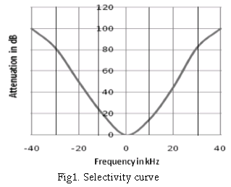
2. Fidelity
- Fidelity of a receiver is its ability to reproduce the exact replica of the transmitted signals at the receiver output.
- For better fidelity, the amplifier must pass high bandwidth signals to amplify the frequencies of the outermost sidebands, while for better selectivity the signal should have narrow bandwidth. Thus a trade off is made between selectivity and fidelity.
- Low frequency response of IF amplifier determines fidelity at the lower modulating frequencies while high frequency response of the IF amplifier determines fidelity at the higher modulating frequencies.
3. Sensitivity
- Sensitivity of a receiver is its ability to identify and amplify weak signals at the receiver output.
- It is often defined in terms of voltage that must be applied to the input terminals of the receiver to produce a standard output power which is measured at the output terminals.
- The higher value of receiver gain ensures smaller input signal necessary to produce the desired output power.
- Thus a receiver with good sensitivity will detect minimum RF signal at the input and still produce utilizable demodulated signal.
- Sensitivity is also known as receiver threshold.
- It is expressed in microvolts or decibels.
- Sensitivity of the receiver mostly depends on the gain of IF amplifier.
- It can be improved by reducing the noise level and bandwidth of the receiver.
- Sensitivity can be graphically represented as a curve shown in Fig Below, which depicts that sensitivity varies over the tuning band.
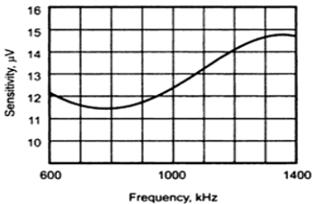
Fig2. Sensitivity curve

- What is mean by signal –to- noise ratio? Discuss the importance of SNR in radio receiver
- It is defined as the ration of signal power to the noise power at the same point.
∴ SN=PsPn
Where
Ps = Signal power
Pn = Noise power at the same point.
- The signal to noise ratio is normally expressed in dB and the typical values of S/N ratio range from about 10 dB to 90 dB.
- Higher the values of S/N ratio better the system performance in presence of noise.
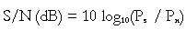
- The power can be expressed in terms of signal and noise voltages as follows:
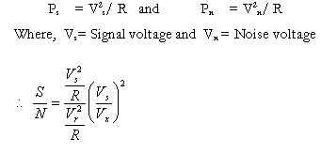
- The signal to noise ration in dB is given by,
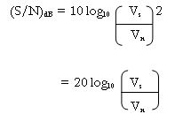

Importance of SNR in radio receiver: (Draw the diagram to show that the signal is high and noise is low)
- The noise performance and the signal to noise ratio is a key parameter for any radio receiver.
- The signal to noise ratio or SNR as it is often termed is a measure of the sensitivity performance of a receiver.
- There are a number of ways in which the noise performance and the sensitivity of a radio receiver can be measured. The most obvious method is to compare the signal and noise levels for a known signal level, i.e. the signal to noise (S/N) ratio or SNR.
- Obviously the greater the difference between the signal and the unwanted noise, i.e. the greater the S/N ratio or SNR, the better the radio receiver sensitivity performance.

- Explain White Gaussian Noise
White Noise:
The white noise contains all the frequency components in equal proportion. This is analogous with white light which is a superposition of all visible spectral Components.

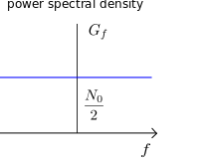
Guassian Noise:
The white noise has a gaussian distribution. That means the probability desity function of the white noise has the shape of the gaussian probability desity function. Therefore this is called as guassian noise
The power spectral density of white noise,
S_{n}(f) = N₀ /2
The equation implies the power spectral density of white noise is independent of frequency.

- Explain any two types of Wired Communication Channel
Twisted Pair Wire:
- Twisted pair wire consists of two wires twisted together a specific number of times to create a magnetic field that reduces the amount of interference in the line.
- In shielded twisted pair (STP), the twisted core is placed into a cladding shield, which is wrapped with wires to absorb any interference. Used when you have to pack many wires together in a small space or in an environment with a lot of electrical equipment. STP wires are reliable in high-speed areas.
- In unshielded twisted pair (UTP), the twisted core is just covered with the plastic material without the use of cladding material. Often used in telephone systems.
UTP lines are grouped into categories based on their quality and use.
Coaxial Cable:
- Coaxial cable is composed of a single copper wire (the inner conductor), surrounded by a insulating cladding material called a shell. The shell is then surrounded by a second conductor (usually a braided copper shield), which gives the cable the ability to transmit much more data than a twisted pair wire. Finally, the entire cable is enclosed in a rubber outer cladding called the jacket.
- Coaxial cables allow the use of broadband and baseband transmission. In broadband transmission, a single cable is divided into many channels, each of which can carry a different transmission. The carrier wave is divided into bandwidths and separated by guardbands to prevent interference between the signals. In baseband transmission, only a single signal is transmitted over the cable.
- A single coaxial cable can carry 1,000 simultaneous voice and data transmissions.

- Explain Energy and Power Signals
Energy Signal:
A signal is referred to as an Energy signal if and only if the total energy of the signal satisfies the condition 0<E<$∞$
E = $\int_{-∞}^{∞}{| x\left(t\right)}$²| dt
Power Signal:
A signal is referred to as an Power signal if and only if the average power of the signal satisfies the condition 0<P<$∞$
P =$\lim_{t→∞}{1/T}$ $\int_{–T/2}^{T/2}{x\left(t\right)}$ dt

- Explain Baseband and Bandpass signal
Baseband Signal:
The baseband is defined as a transmission signal that contains more than just a single frequency from 0 Hz to the highest frequency component. In essence, the baseband is the original signal that is intended to be transmitted. However, this baseband frequency, when transmitted towards its target, can easily be slowed down or can pick up noise and distortion, which is why the original baseband signal must be transmitted into radio frequency. Radio frequency, however, also is at risk for transmission problems, creating the need for a band-pass filter.
Band pass Signal:
The band pass signal is the output of a band-pass filter. It is a signal that corresponds to the settings of the band-pass filter. While baseband is the original signal, passband is the filtered signal. Passband is more technically defined as the portion of the spectrum between limiting frequencies with minimum relative loss or maximum relative gain. Given the earlier example, a radio tuner set at 107.5 MHz will allow only 107.5 MHz to pass through. Anything below or above 107.5 MHz will be blocked by the filter.
- Explain Bandwidth with neat diagram and give some examples
- Bandwidth can be defined as the portion of Electromagnetic spectrum occupied by the signal
- Bandwidth is the capacity of a wired and wireless network communications link to transmit the maximum amount of data from one point to another over a computer network.
- Bandwidth is the difference between upper and lower frequency limits of signal
- Each frequency has its own frequency range This frequency range of signal is called Bandwidth.

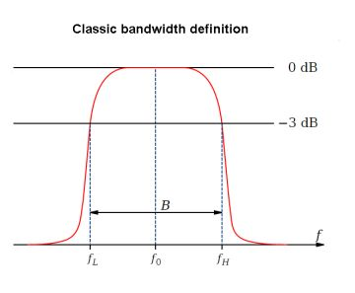
Example : the range of music signal is 20Hz to 15Khz
BW = f₂ – f₁
= 15Khz – 20Hz
= 14980Hz
- Draw and Explain the block diagram of the communication system

Block Diagram of Communication System
Fig. shows the block diagram of a general communication system, in which the different functional elements are represented by blocks.
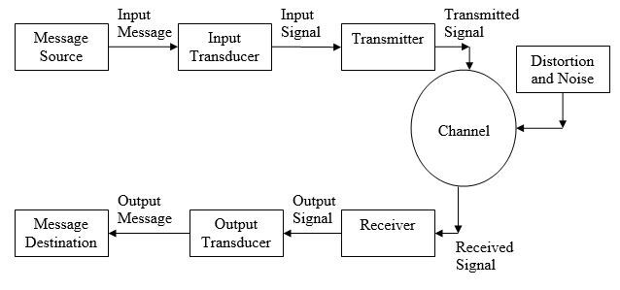
The essential components of a communication system are information source, input transducer, transmitter, communication channel, receiver and destination.

(i) Information Source
In general, there can be various messages in the form of words, group of words, code, symbols, sound signal etc. However, out of these messages, only the desired message is selected and communicated.
Therefore, we can say that the function of information source is to produce required message which has to be transmitted.

(ii) Input Transducer
A transducer is a device which converts one form of energy into another form.
The message from the information source may or may not be electrical in nature. In a case when the message produced by the information source is not electrical in nature, an input transducer is used to convert it into a time-varying electrical signal.
For example, in case of radio-broadcasting, a microphone converts the information or massage which is in the form of sound waves into corresponding electrical signal.

Transmitter
The function of the transmitter is to process the electrical signal from different aspects.
For example in radio broadcasting the electrical signal obtained from sound signal, is processed to restrict its range of audio frequencies (upto 5 kHz in amplitude modulation radio broadcast ) and is often amplified.
In wire telephony, no real processing is needed. However, in long-distance radio communication, signal amplification is necessary before modulation.

The Channel and The Noise
The term channel means the medium through which the message travels from the transmitter to the receiver. In other words, we can say that the function of the channel is to provide a physical connection between the transmitter and the receiver.
Noise is an unwanted signal which tend to interfere with the required signal. Noise signal is always random in character. Noise may interfere with signal at any point in a communication system. However, the noise has its greatest effect on the signal in the channel.

Receiver
The main function of the receiver is to reproduce the message signal in electrical form from the distorted received signal. This reproduction of the original signal is accomplished by a process known as the demodulation or detection. Demodulation is the reverse process of modulation carried out in transmitter.

Destination
Destination is the final stage which is used to convert an electrical message signal into its original form.
For example in radio broadcasting, the destination is a loudspeaker which works as a transducer i.e. converts the electrical signal in the form of original sound signal.
- Explain any two types of Wireless communication Channel
Microwave:
- Microwave transmission uses very-high frequency signals (3,000 MHz to 30 GHz) to transmit signals between stations. The high frequency permits large amounts of data to be transmitted. Unlike broadcast radio signals, which are omni directional, microwave transmission is focused and unidirectional. That means means that microwave stations use line-of-sight transmission and signals travel in straight line. The two types of microwave transmission are terrestrial and satellite:
- Terrestrial microwave transmissions are sent between two microwave stations on the earth (earth station). It is the most common form of long-distance communication.
- Satellite microwave transmissions involve sending microwave transmissions between two or more earth-based microwave stations and a satellite.
Infrared Transmission:
- Infrareds (IR) transmission involves sending light signals at a frequency between visible light and radio waves. Commonly used in TV remote controls, now is used to provide LAN connections.
- It is a line-of-sight transmission and has a maximum coverage of 30 to 80 feet.
- Increasingly, computers and devices such as printers come with IrDA ports, which enable the transfer of data without the use of cables.
4Marks:
11) What are the limitations of TRF receiver. Explain how these limitations are avoided using super-heterodyne receiver.
Disadvantages of TRF receiver
• Poor selectivity and low sensitivity in proportion to the number of tuned amplifiers used.
• Selectivity requires narrow bandwidth, and narrow bandwidth at a high radio frequency implies high Q or many filter sections.
• An additional problem for the TRF receiver is tuning different frequencies. All the tuned circuits need to tune together to the same frequency or track very closely. Another problem to keep the narrow bandwidth tuning. Keeping several tuned circuits aligned is difficult.
• The bandwidth of a tuned circuit doesn’t remain constant and increases with the frequency increase.
• The need to have all RF stages track one another and Instability due to large number of RF stages.
• Received bandwidth increases with frequency (varies with center frequency)
• Gain is non-uniform over a wide range of frequencies.
Advantages of the super-heterodyne receiver include,
• IF stage permits use at very high frequencies.
• Because many components operate at the fixed IF, they can be optimized.
• Less expensive.
• Better selectivity
• Improved circuit stability.
• Uniform gain over a wide range of frequencies
Use of the fixed lower IF channel gives the following advantages:
      - for a given Q factor in the tuned circuits, the bandwidth is lower making it easier to achieve the required selectivity.
      - At lower frequencies, circuit losses are often lower allowing higher Q factors to be achieved and hence, even greater selectivity and higher gain in the tuned circuits.
      - It is easier to control, or shape, the bandwidth characteristic at one fixed frequency. Filters can be easily designed with a desired Band-pass characteristic and slope characteristic, an impossible task for circuits which tune over a range of frequencies.
      - Since the receiver selectivity and most of the receiver pre-detection gain, are both controlled by the fixed IF stages, the selectivity and gain of the super-heterodyne receiver are more consistent over its tuning range than in the TRF receiver.
16) Define signal-to-noise ratio. Explain the effect of cascade connection on a signal-to-noise ratio. An amplifier with 10dB noise figure and 4dB noise power gain is cascaded with a second amplifier which has a 10dB power gain. What is overall noise figure and power gain.
Signal to Noise Power ratio:
signal-to-noise ratio (S/N) is the ratio of the signal power level to the noise power level.
Mathematically signal-to-noise power ratio is expressed as,
(S/N) = (P_{s} / P_{n})
Where, P_{s} = signal power (watts) , P_{n} = noise power (watts)
The signal-to-noise ratio is often expressed as a logarithmic function with the decibel unit
(S/N)_{db} = 10 log₁₀ (P_{s} / P_{n})

If we use cascaded amplifiers:
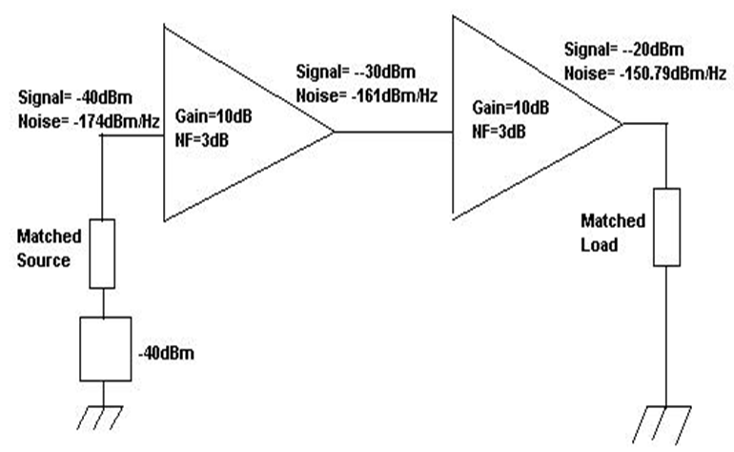
• For above example both amplifiers has 10dB gain and NF=3dB.
The signal goes in at -40dBm with a noise floor at kTB (-174dBm/Hz).
We can calculate that the signal at the output of the first amplifier is -30dBm and the noise is:(-174dBm/Hz input noise) + (10dB of gain) + (3dB NF) = -161dBm/Hz.
Let see how many kTBs are entering in the second amplifier:
(-161dBm/Hz) is 13dB greater than kTB (-174dBm13dB is a power ratio of 20x. So, the noise floor at the second amplifier is 20 times kTB or 20kTB.
• Next calculate how many kTBs are added by the noise source of the second amplifier (in this case, 1kTB because the NF=3dB).
• Finally calculating the increase in noise floor at the second amplifier as a ratio and convert to dB.
Ratio of (input noise floor) + (added noise) to (input noise floor) is: (20kTB+1kTB) / (20kTB) = 20/21 In dB = 10LOG (21/20) = 0.21dB
• Therefore, the second amplifier only increases the noise floor by 0.21dB even though it has a noise figure of 3dB, simply because the noise floor at its input is significantly higher than kTB. The first amplifier degrades the signal to noise ratio by 3dB, while the second amplifier degrades it only 0.21dB.
• When amplifiers are cascaded together in order to amplify very weak signals, it is generally the first amplifier in the chain which will have the greatest influence upon the Signal to noise ratio because the noise floor is lowest at that point in the chain.

